Supplementary files for “Confirmation of Mg/Ca ratios as palaeothermometers in Atlantic limpet shells”

**Authors: Niklas Hausmann, Donna Surge, Ivan Briz-Godino**

# Overview

The supplementary files for this study include a comprehensive set of elemental maps and line scans of various *Patella vulgata* and *Nacella* sp. species, which were analysed to reassess the use of Magnesium to Calcium (Mg/Ca) ratios as palaeothermometers in Atlantic limpet shells. These supplementary files are organised by species and specimen identifiers, with both maps and linescans included for each sample.

For each species, the images are grouped to provide a clear comparison between different specimens and sampling techniques. This dataset supports the main findings of the study by offering additional evidence for the reliable use of Mg/Ca ratios in detecting palaeotemperature changes.

# Nacella sp.

### ND-1016-3

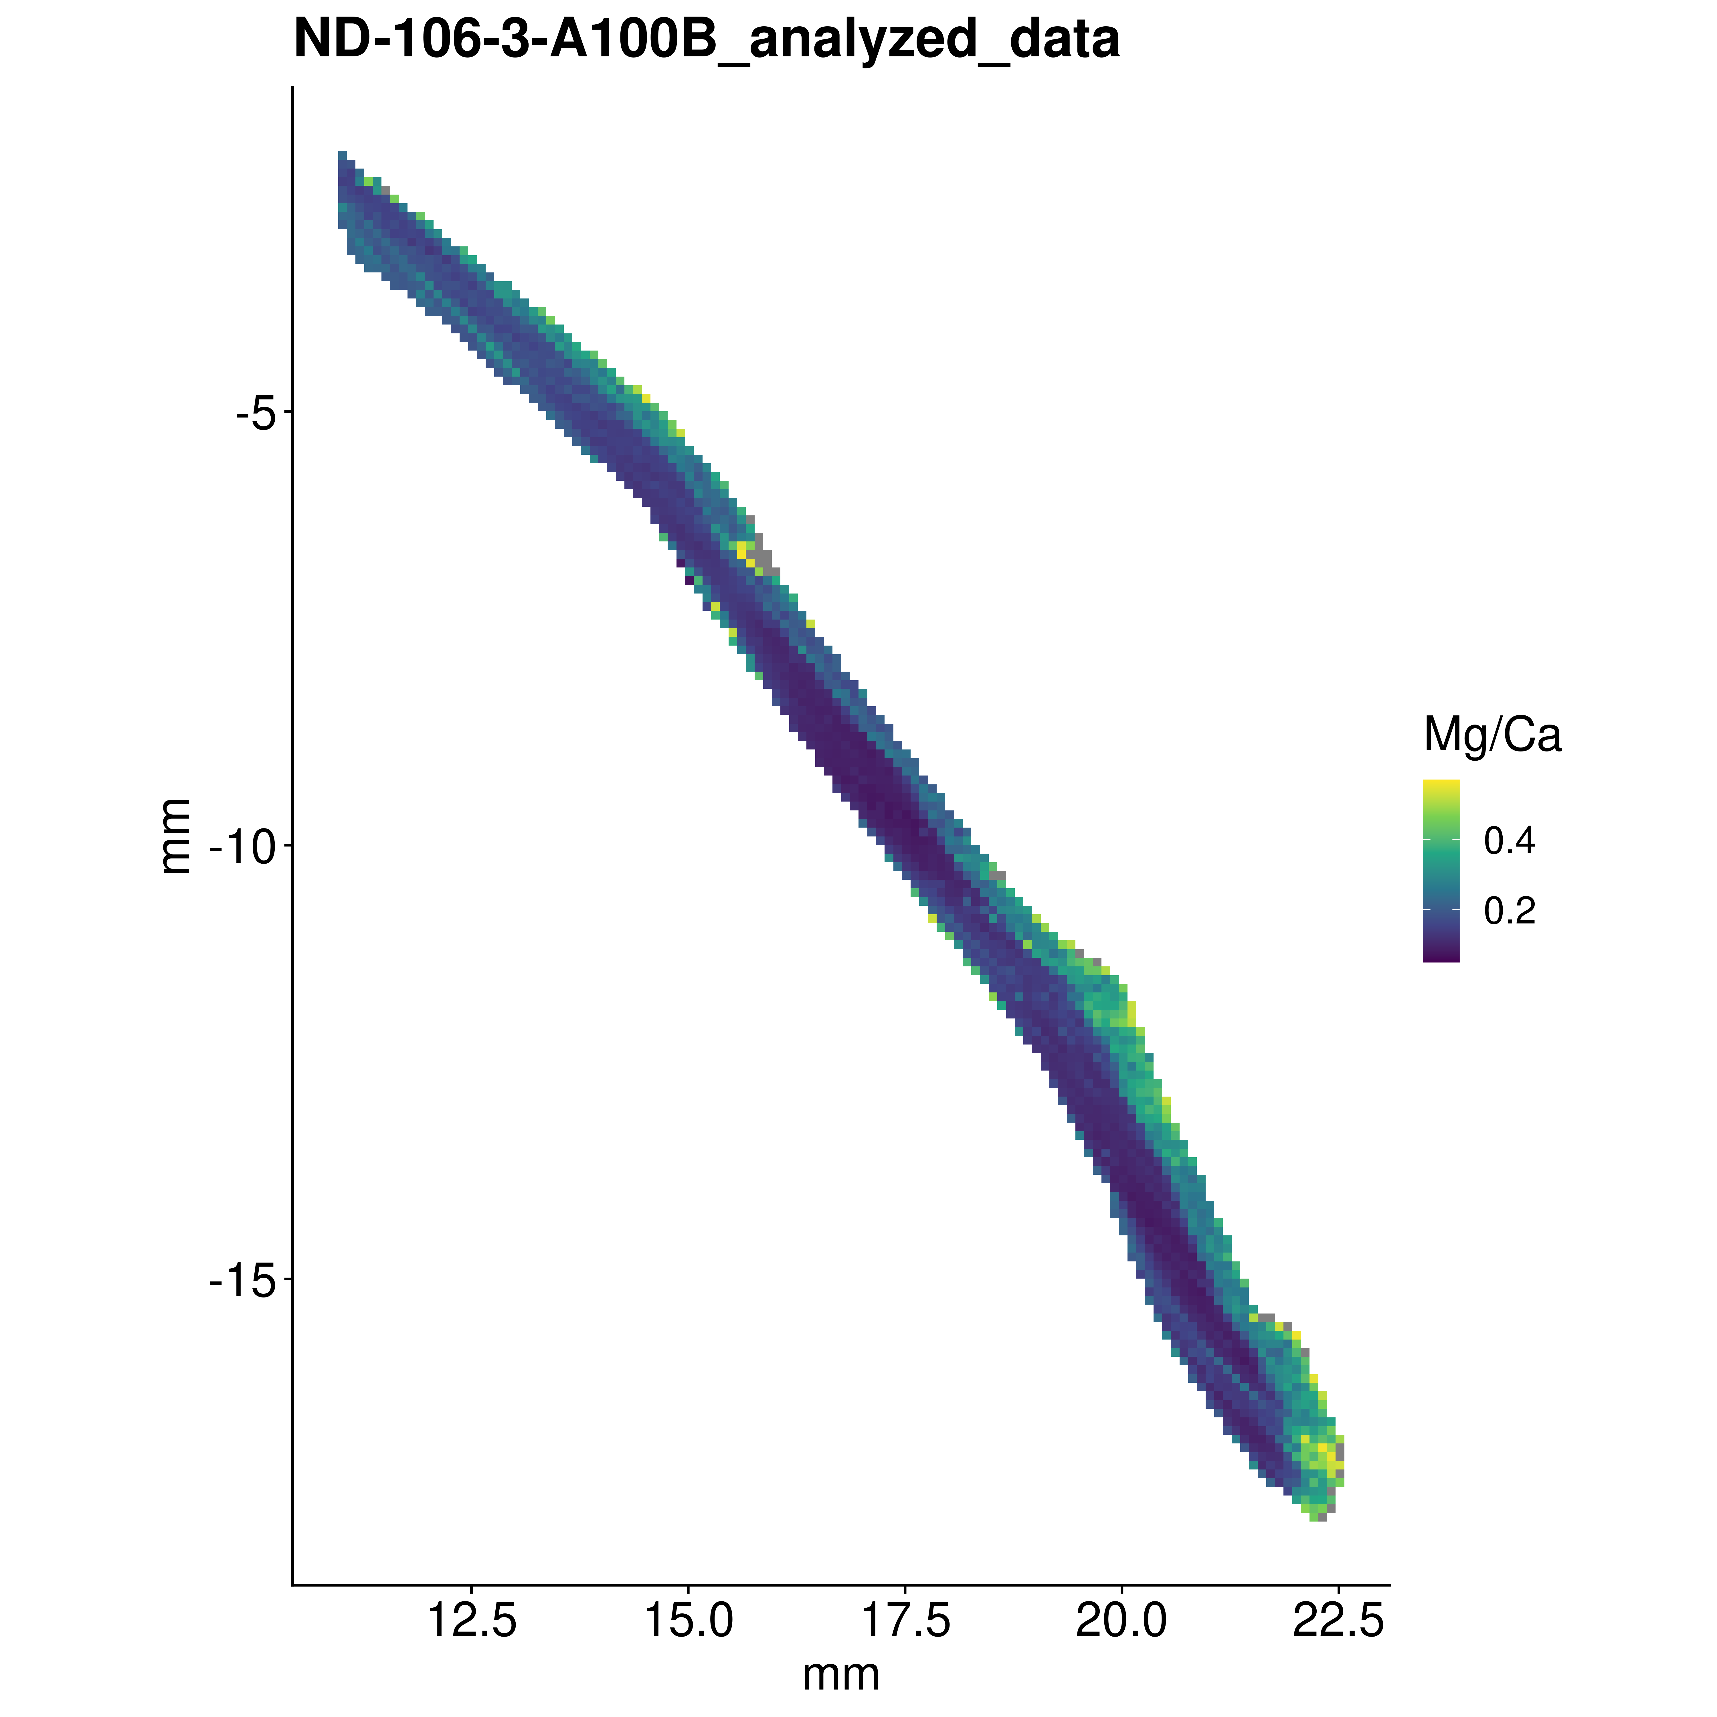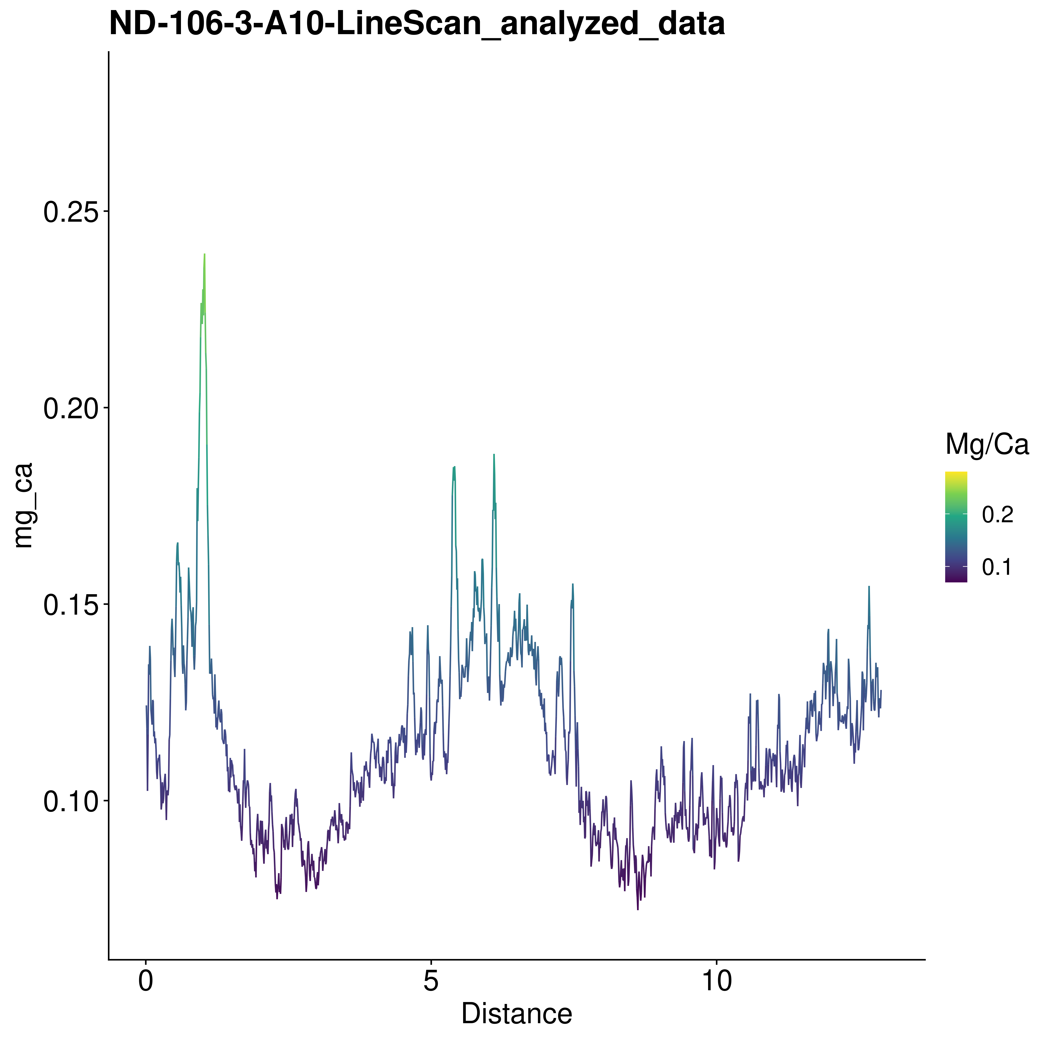

### ND-1016-4

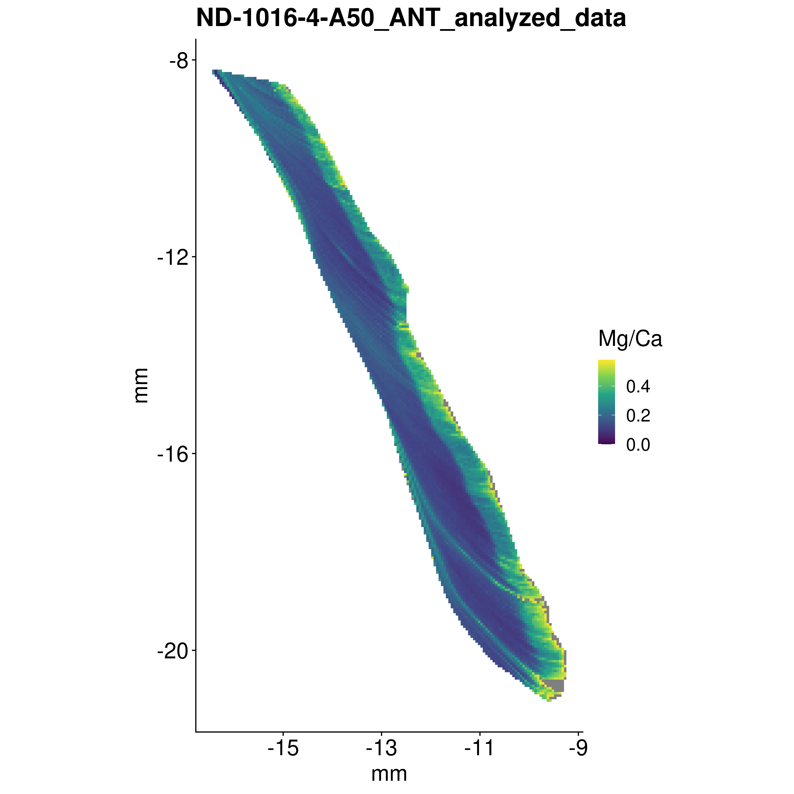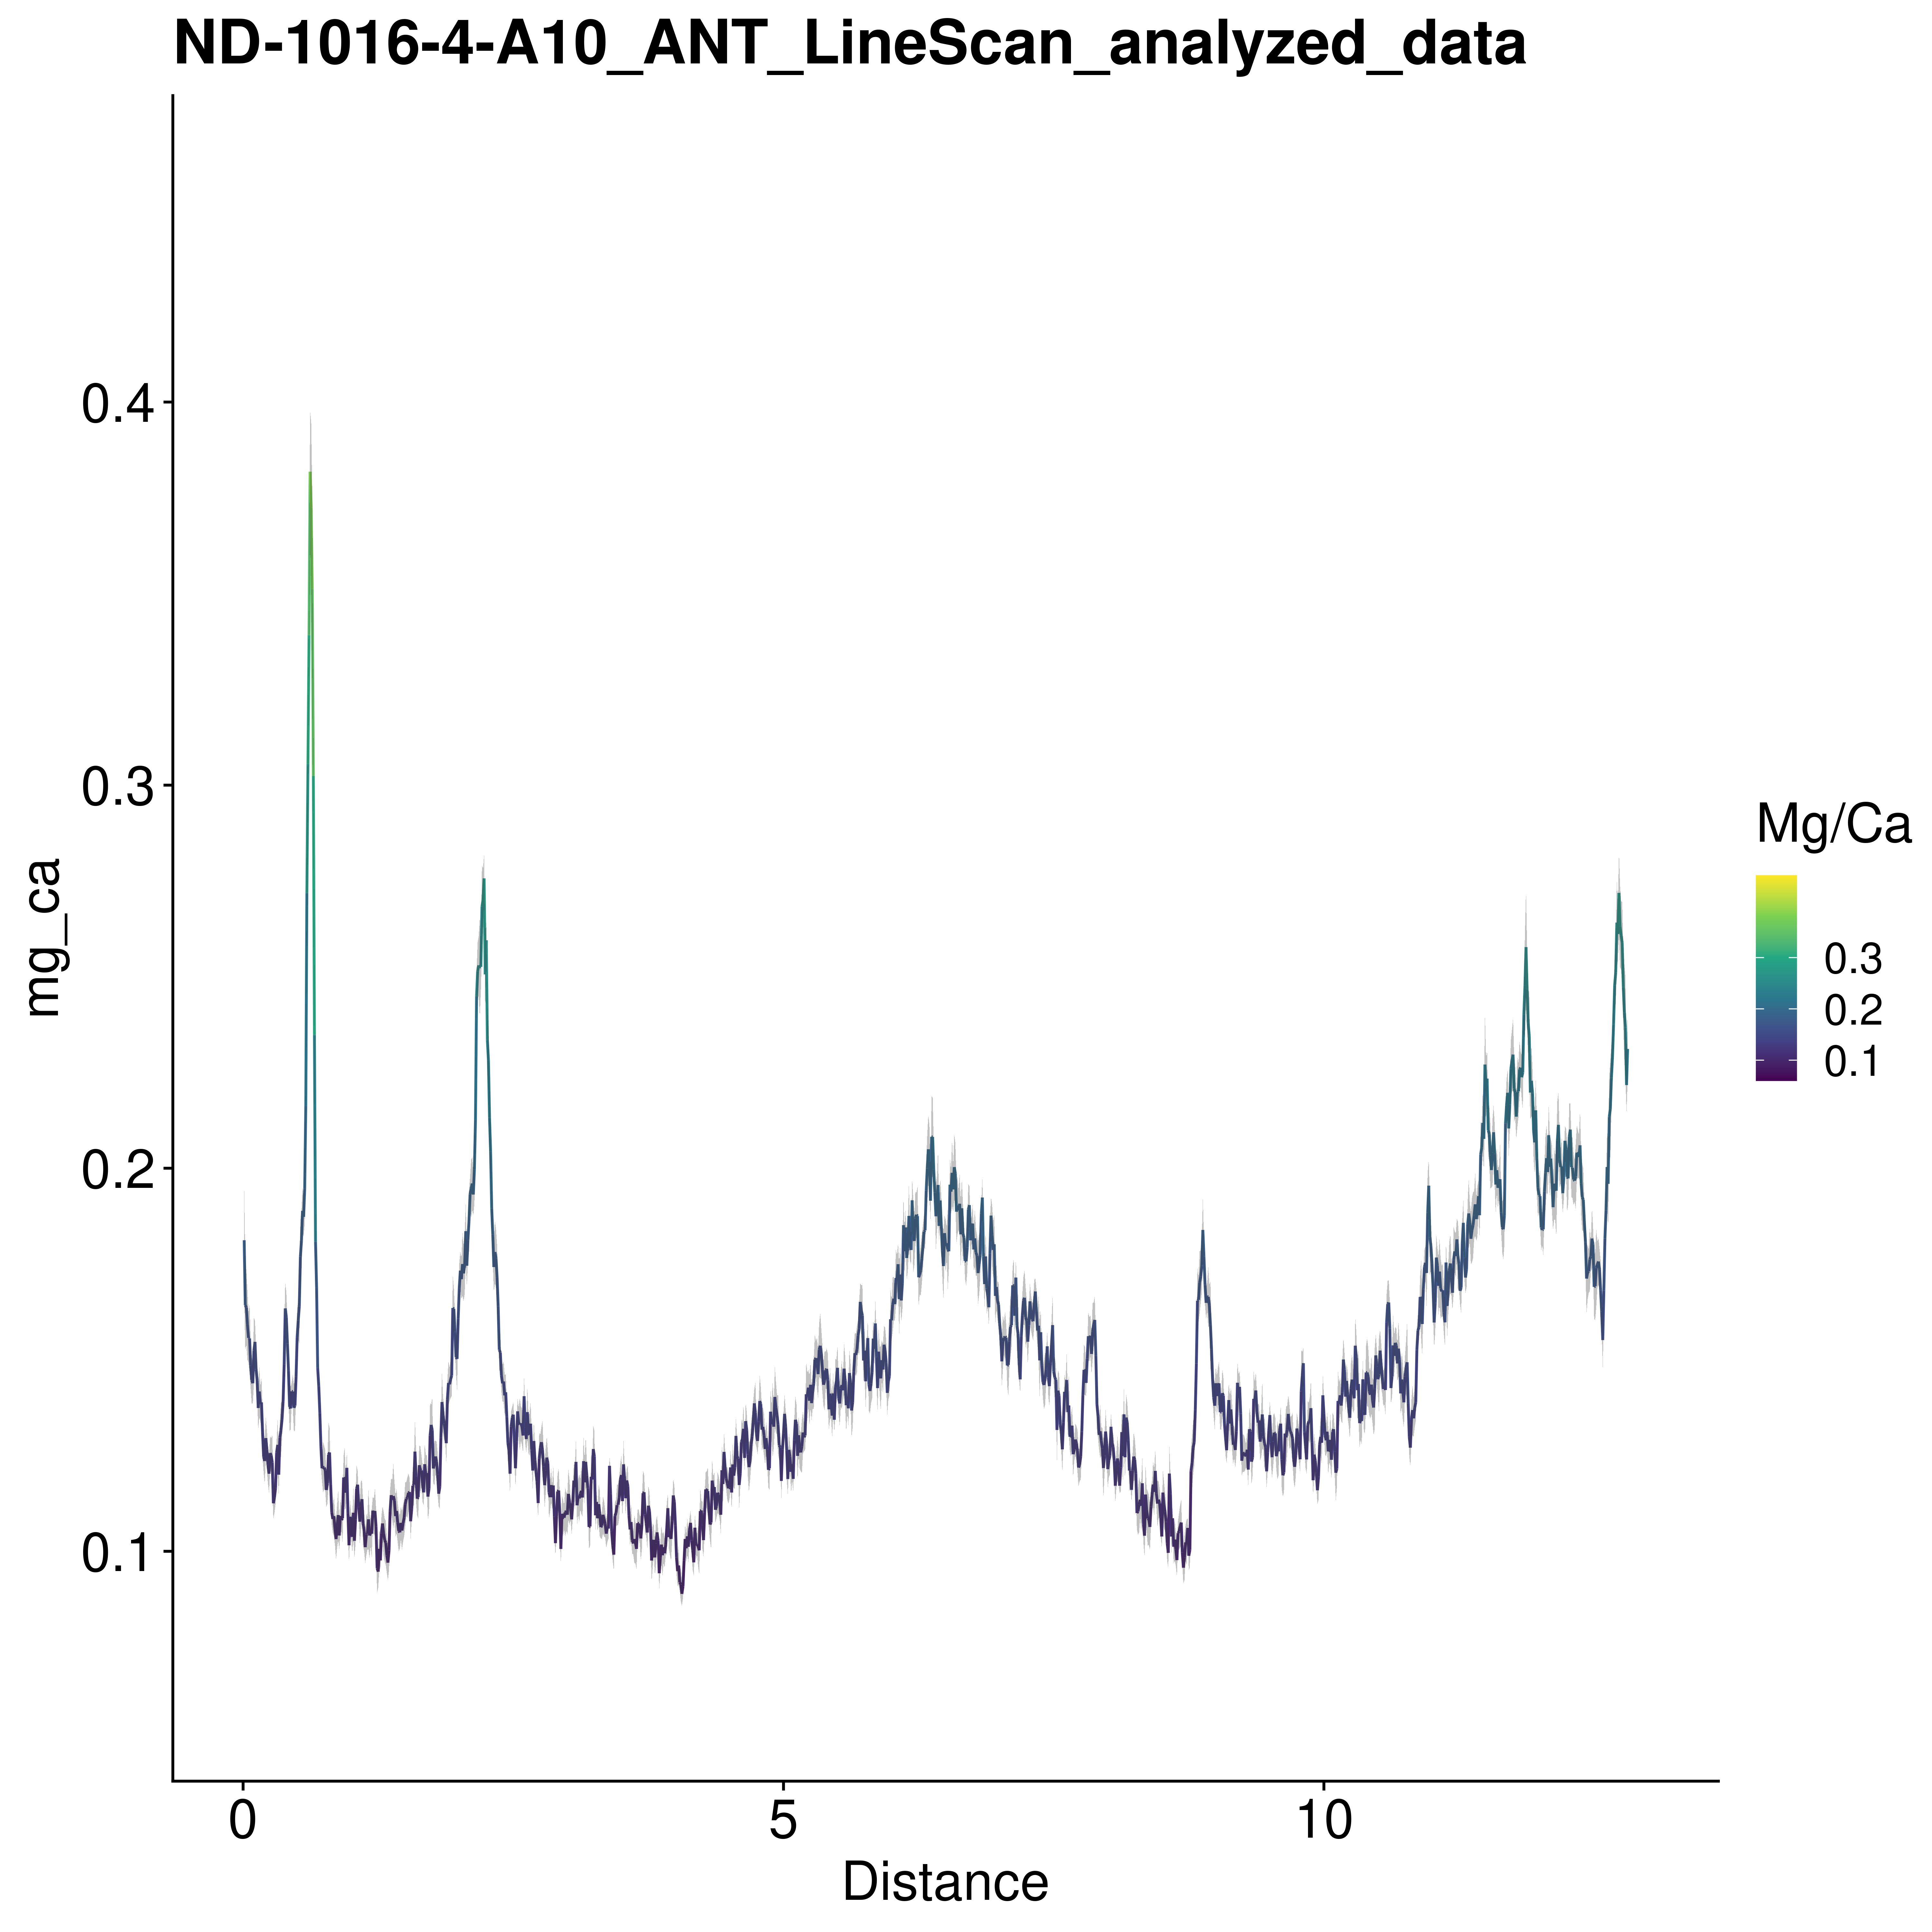

### NM-1016-1

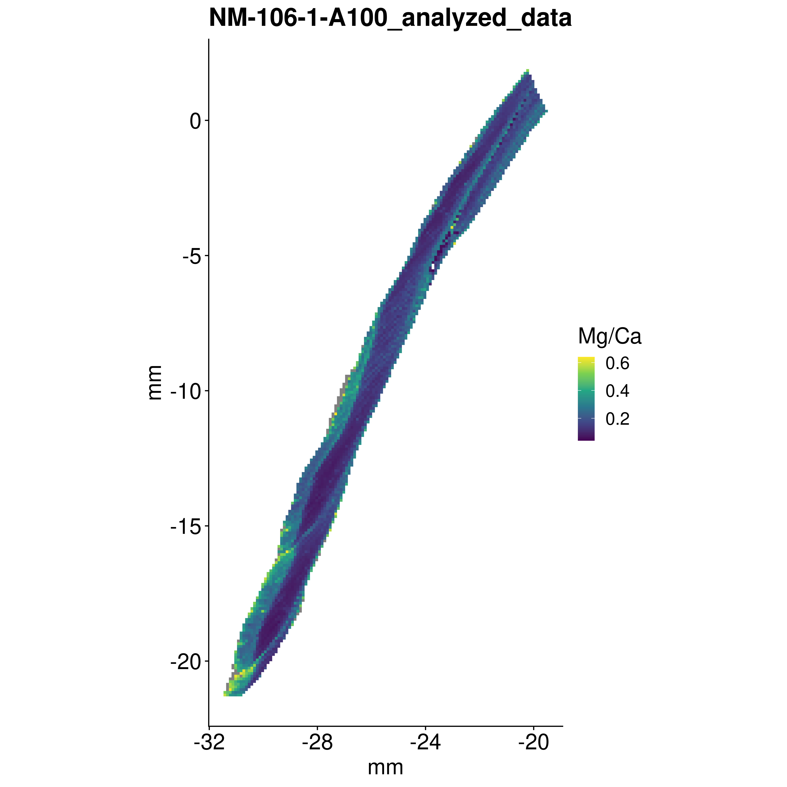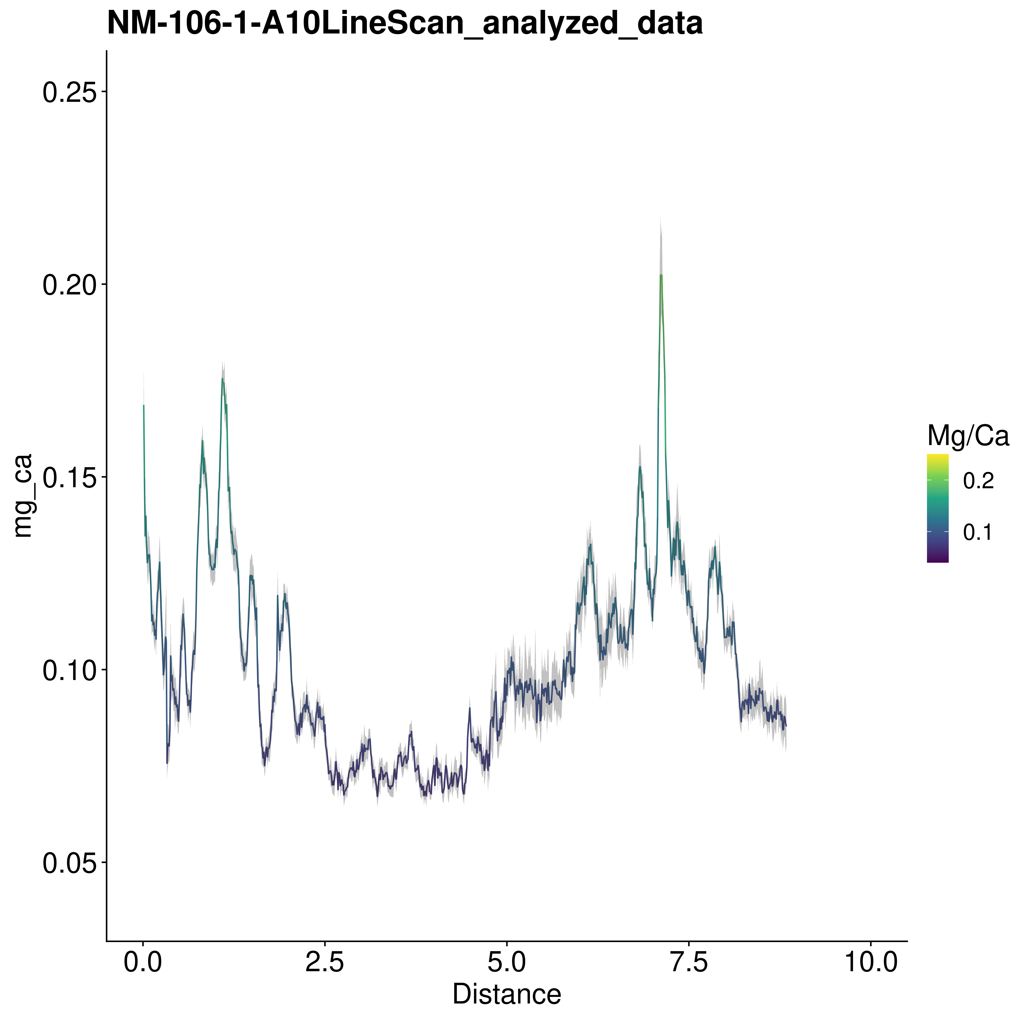

### NM-1016-3

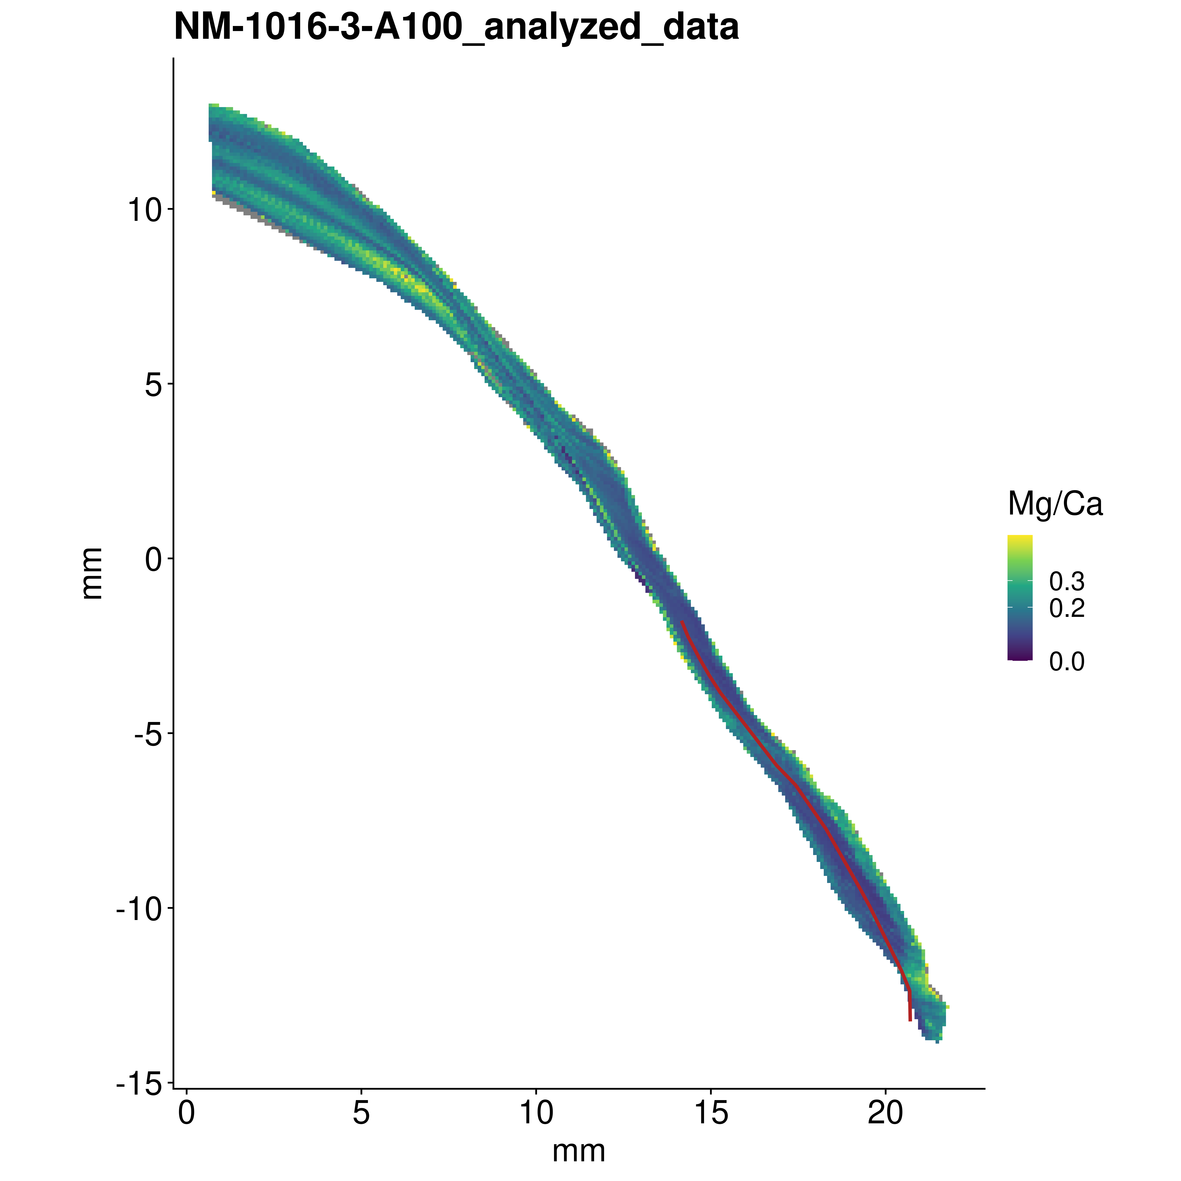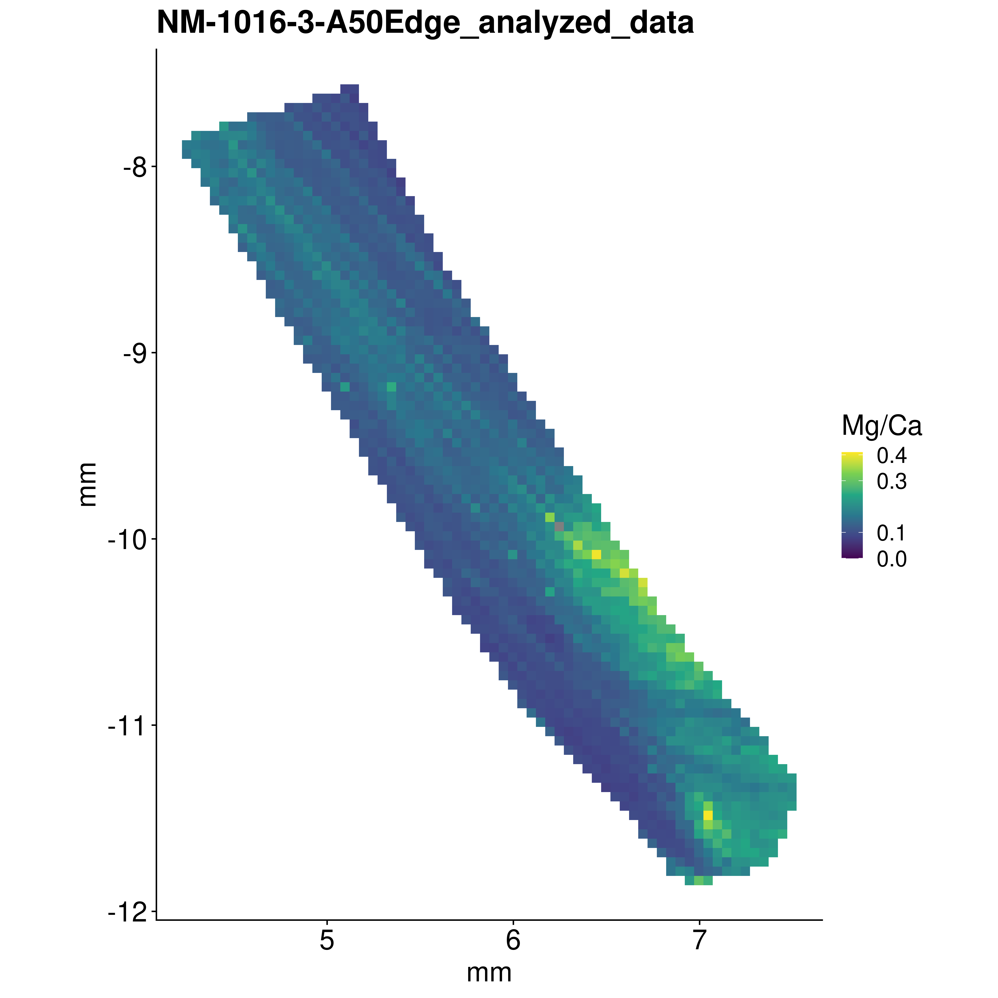

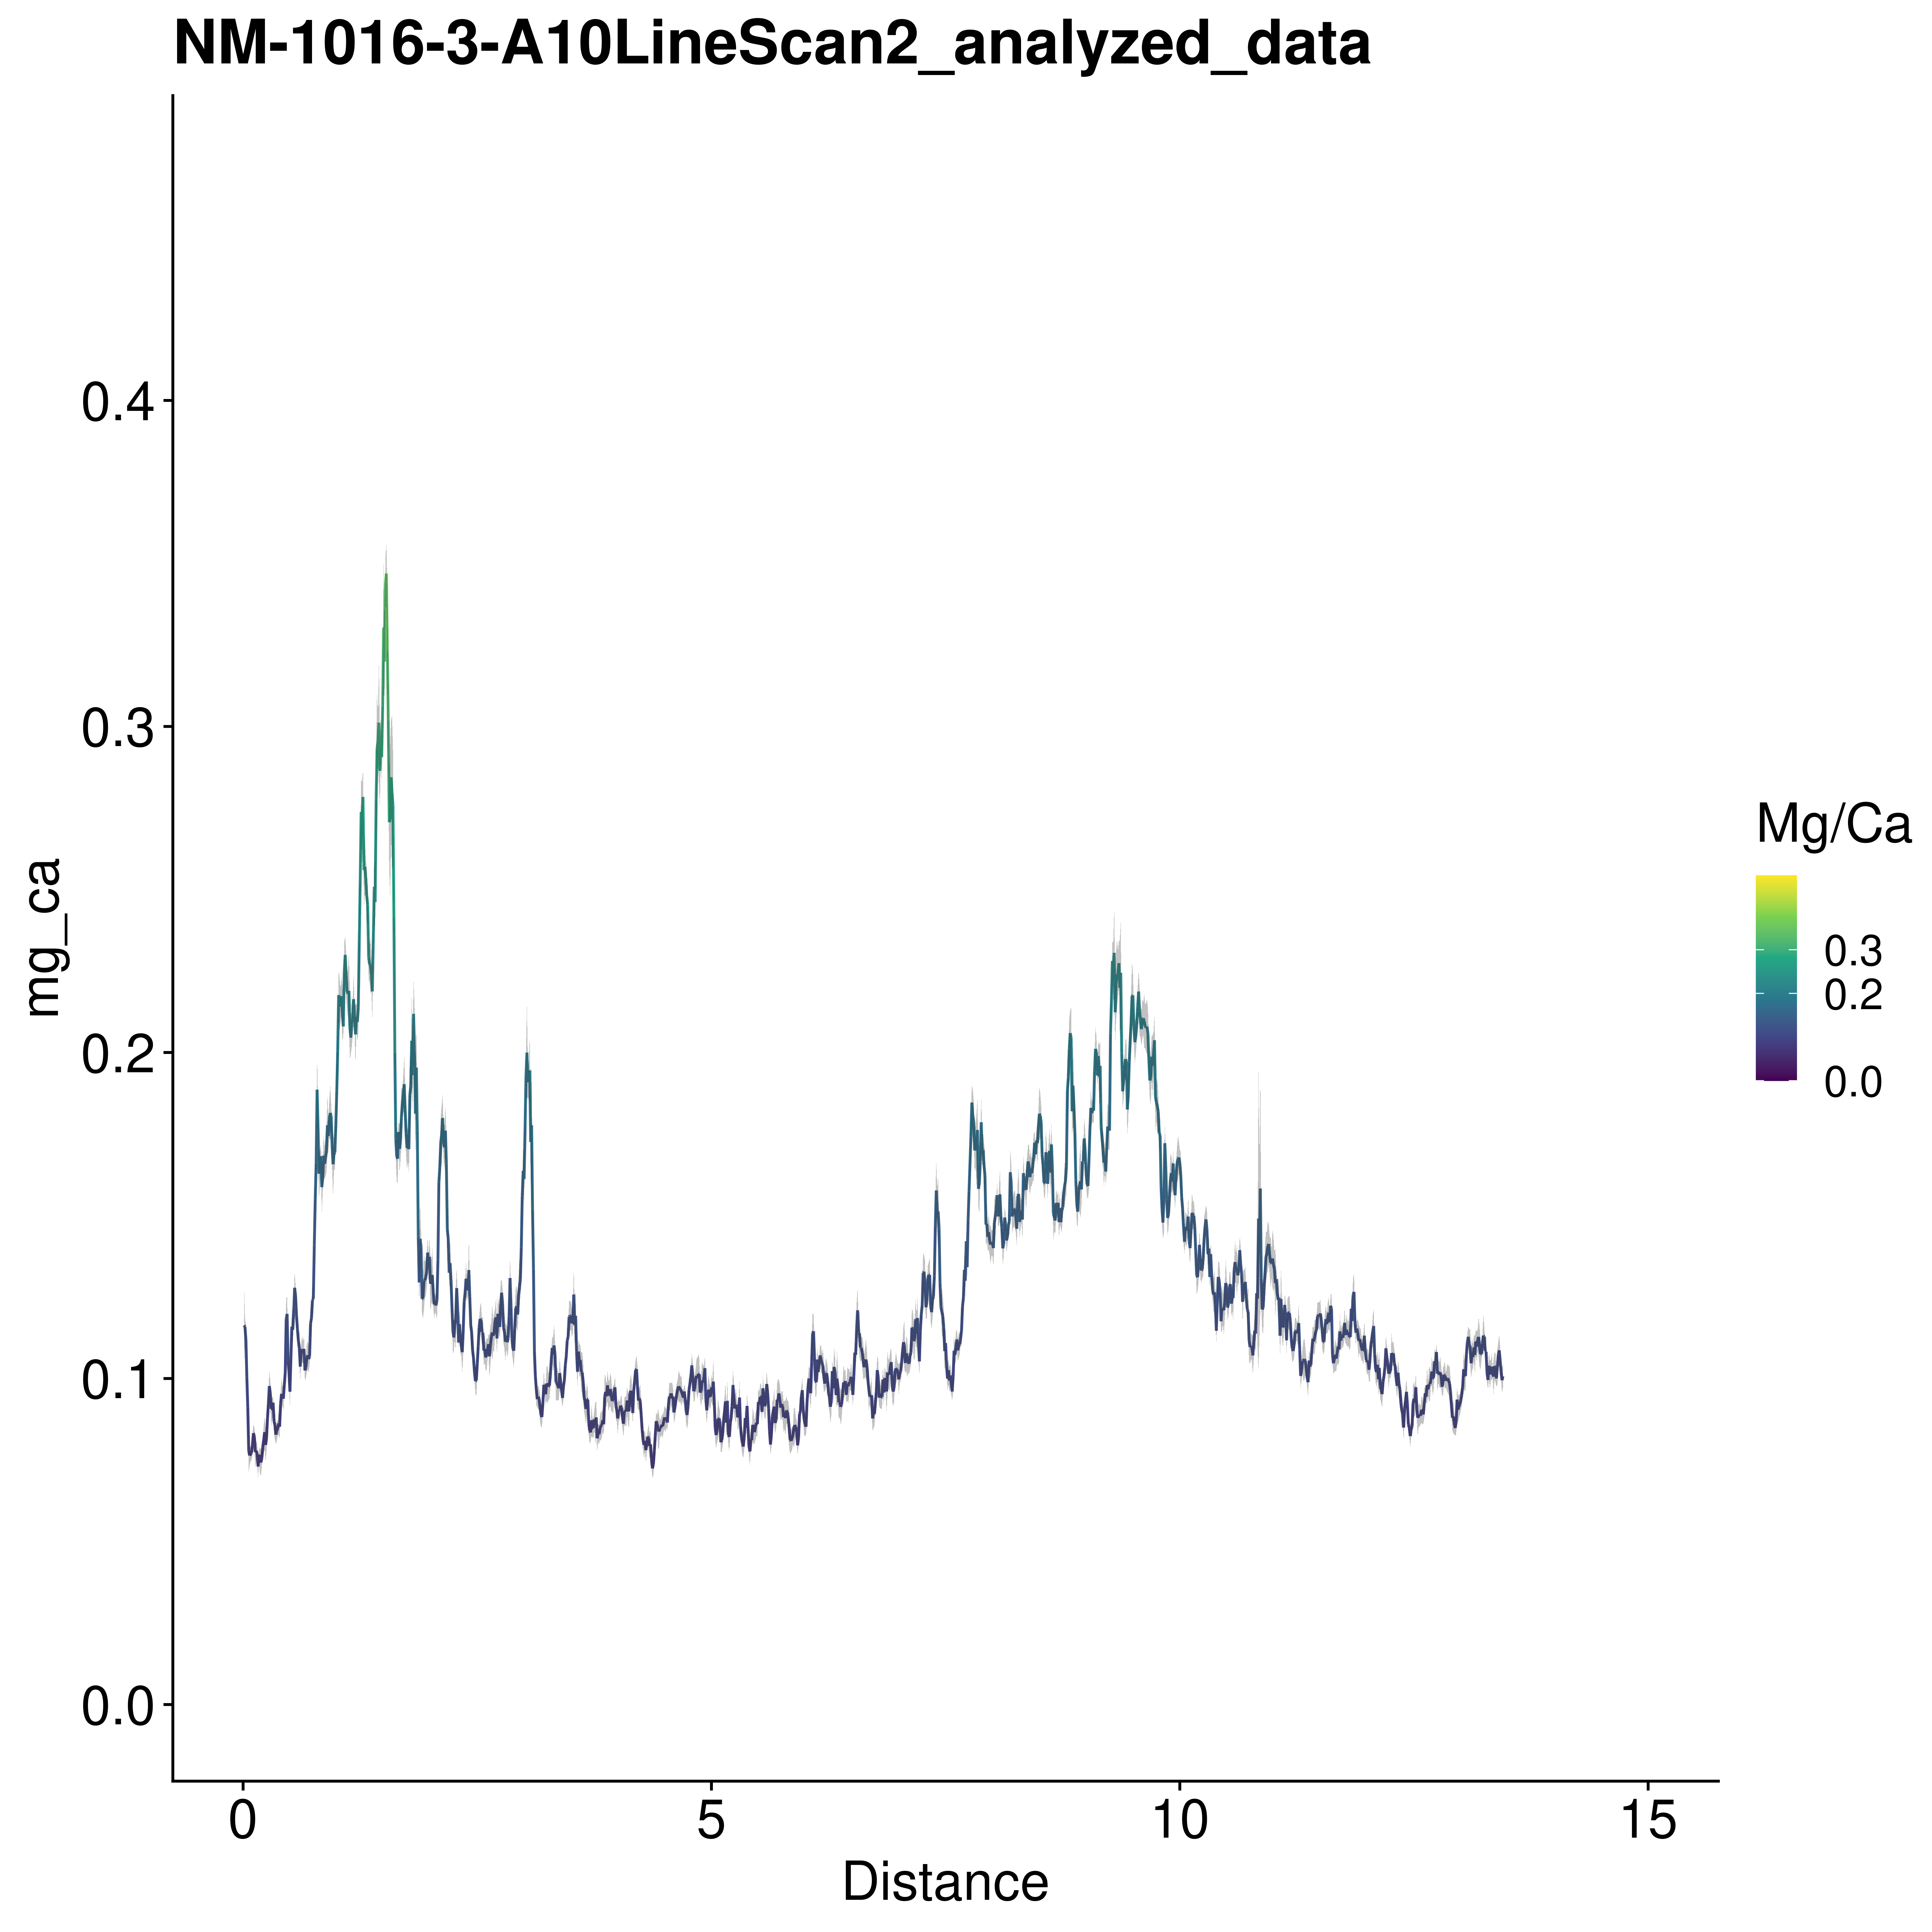

# Patella vulgata

### ORK-LT5

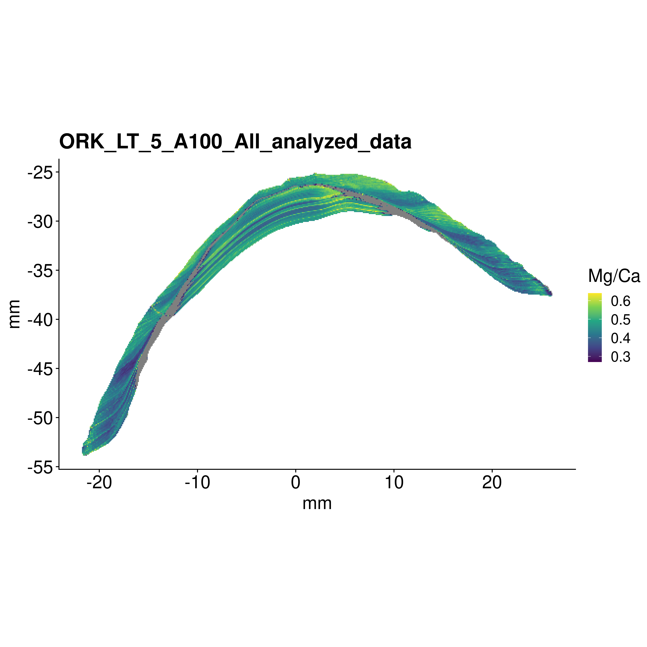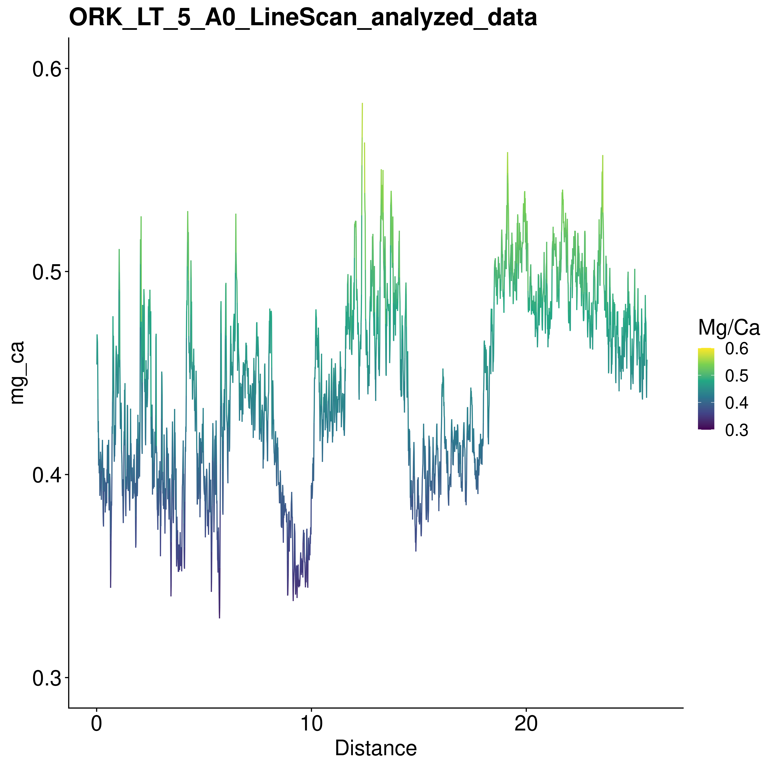

### QG1-7189-2

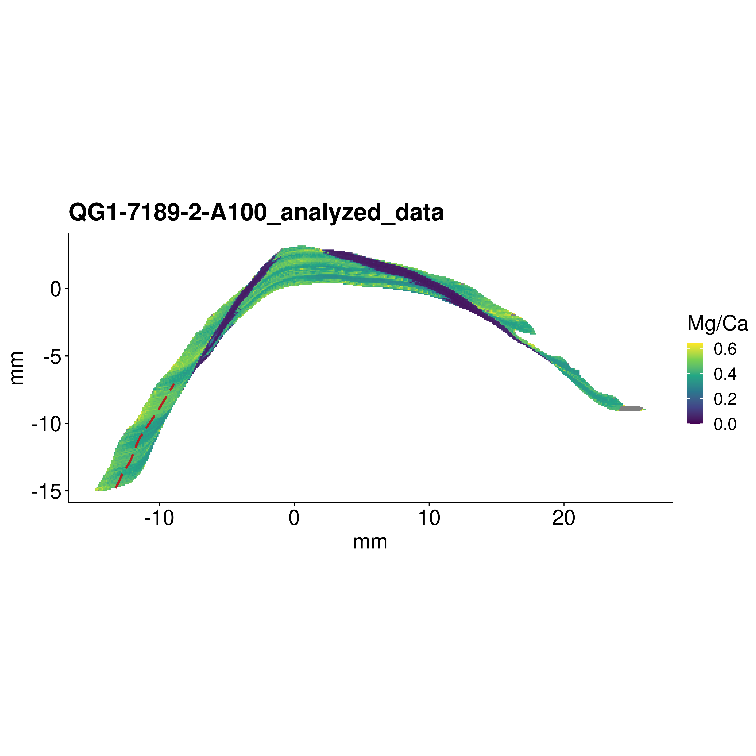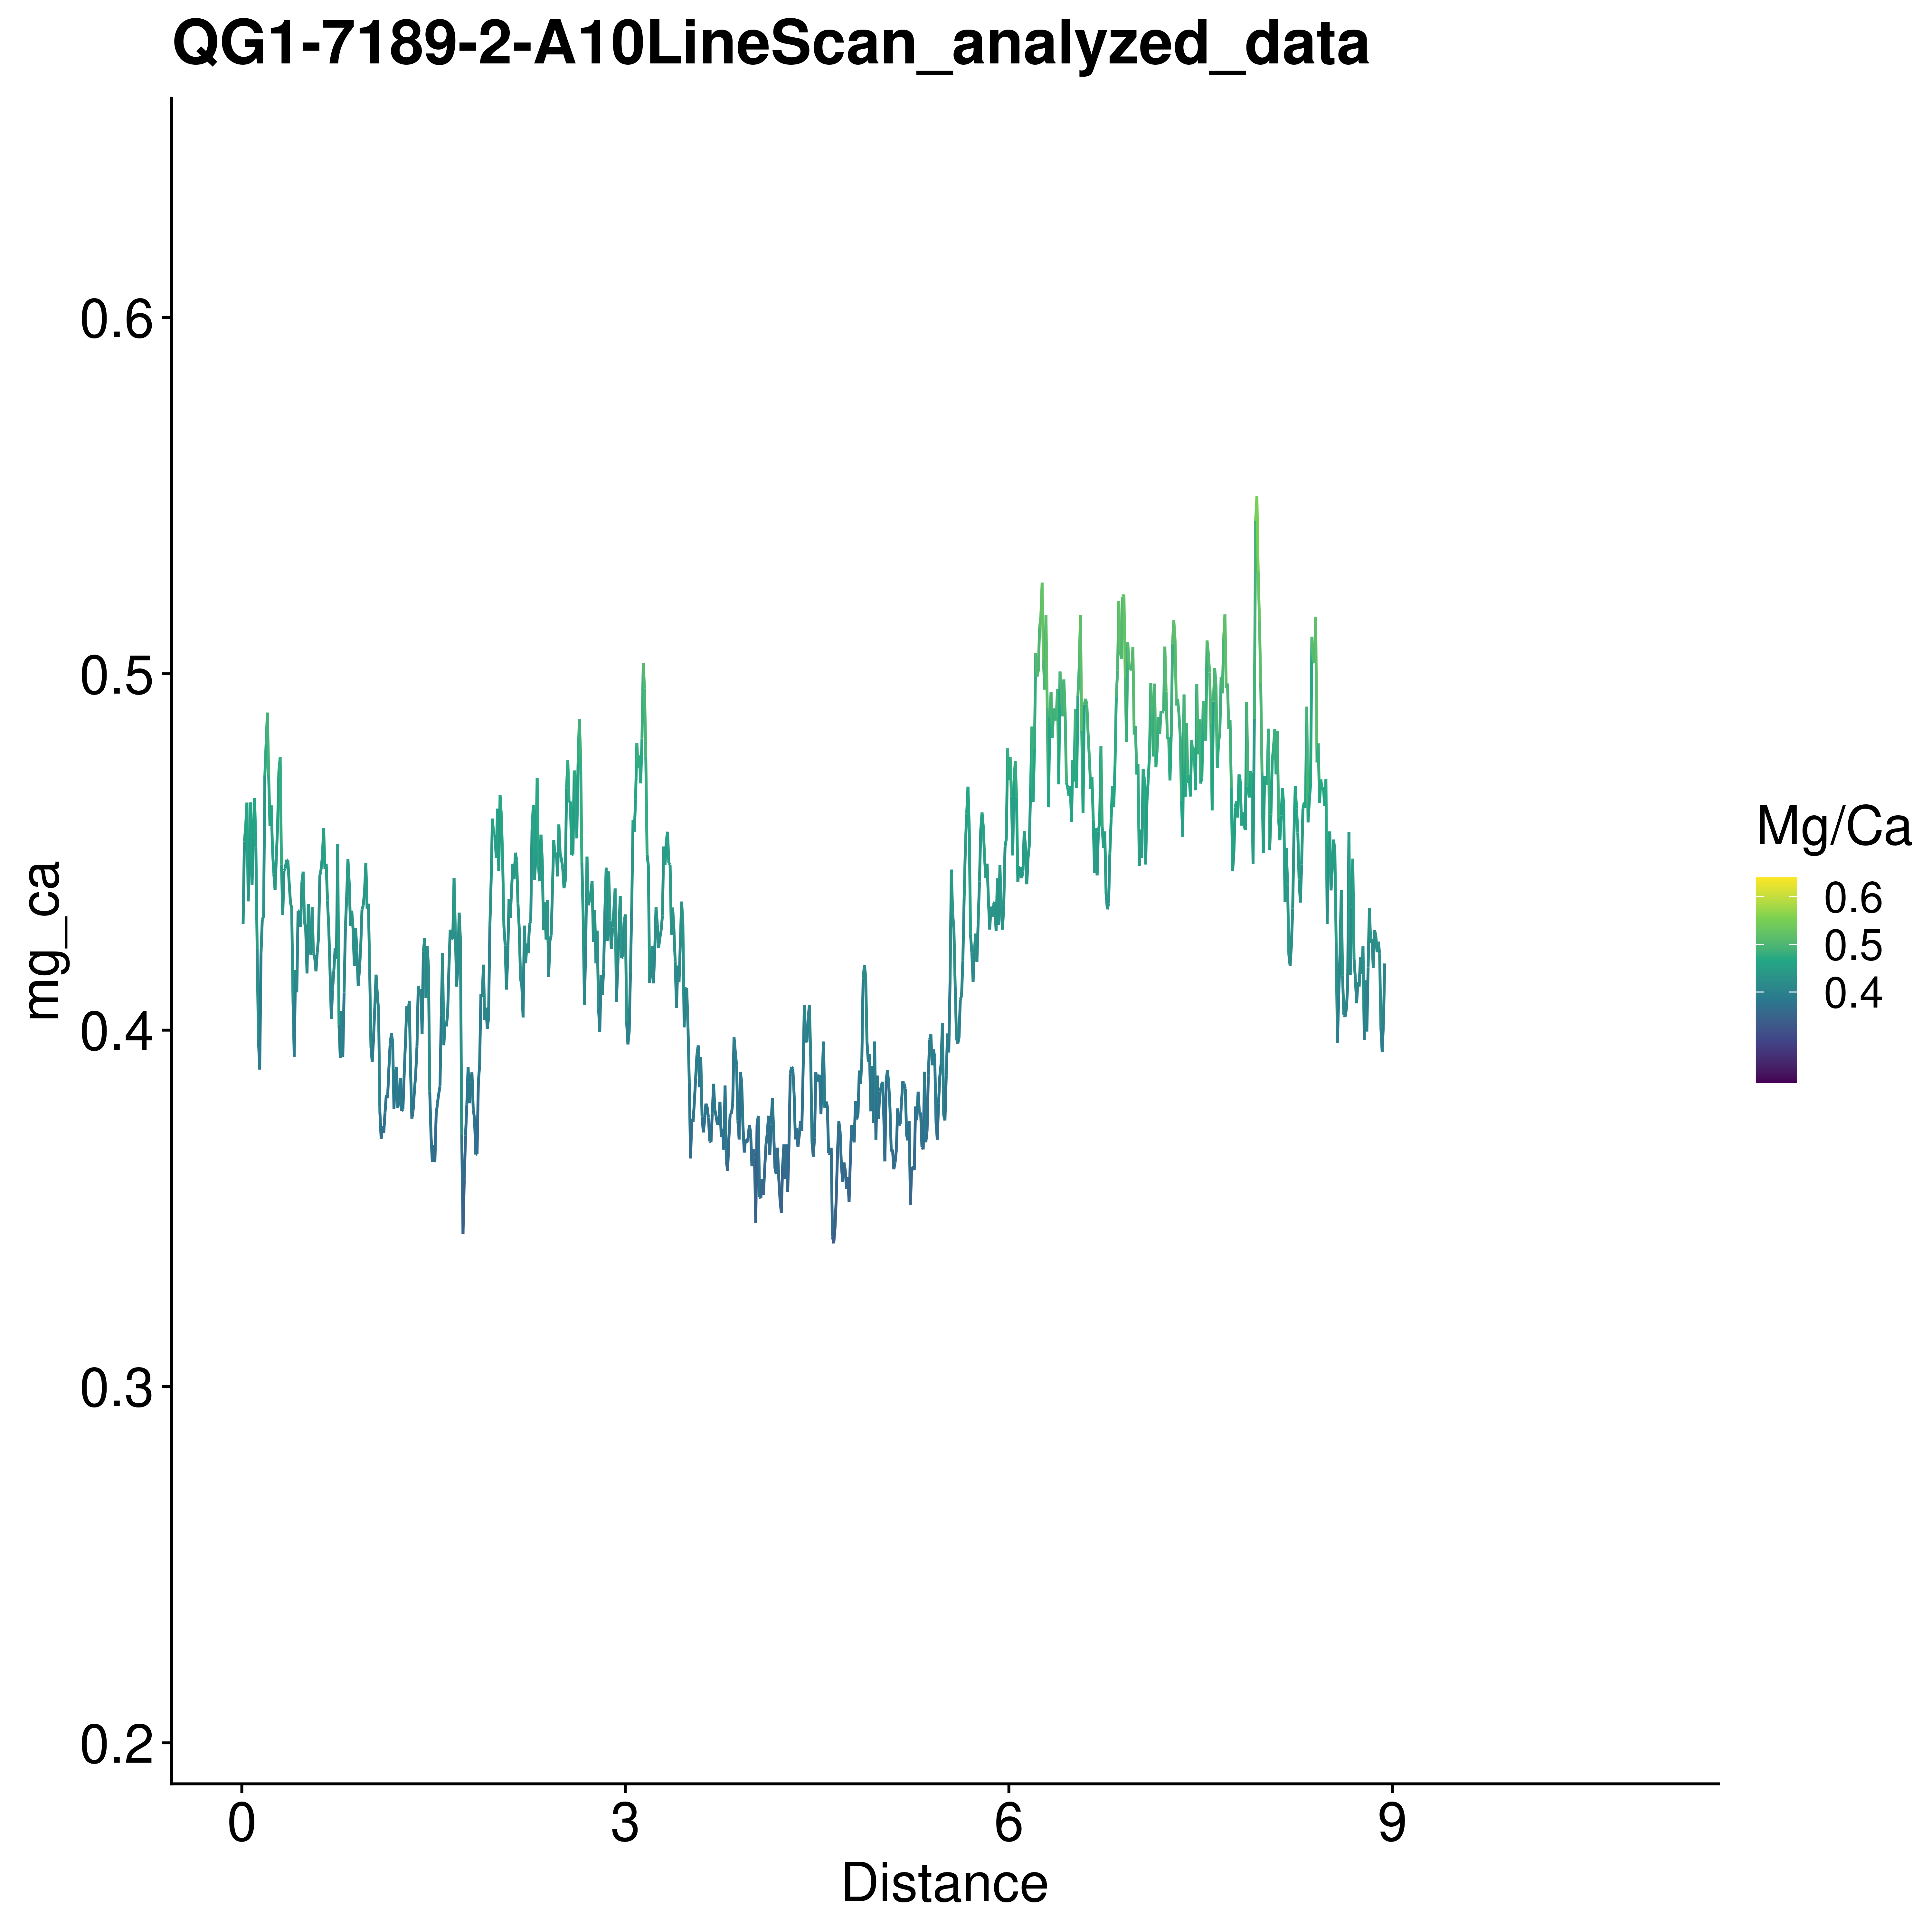

### QG1-7246-1

This shell had a very long lifetime, which made the analysis not as clear as in other shells due to increased time-averaging. Interestingly, the record was also visible in the centre part of the shell, which is shown here.

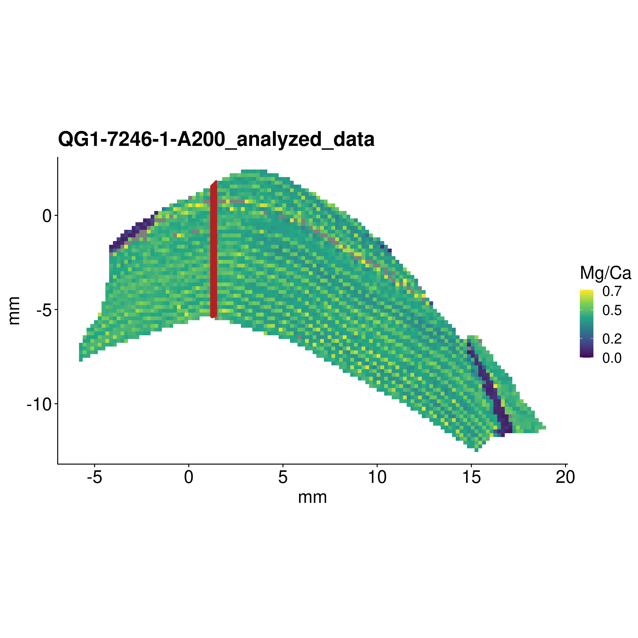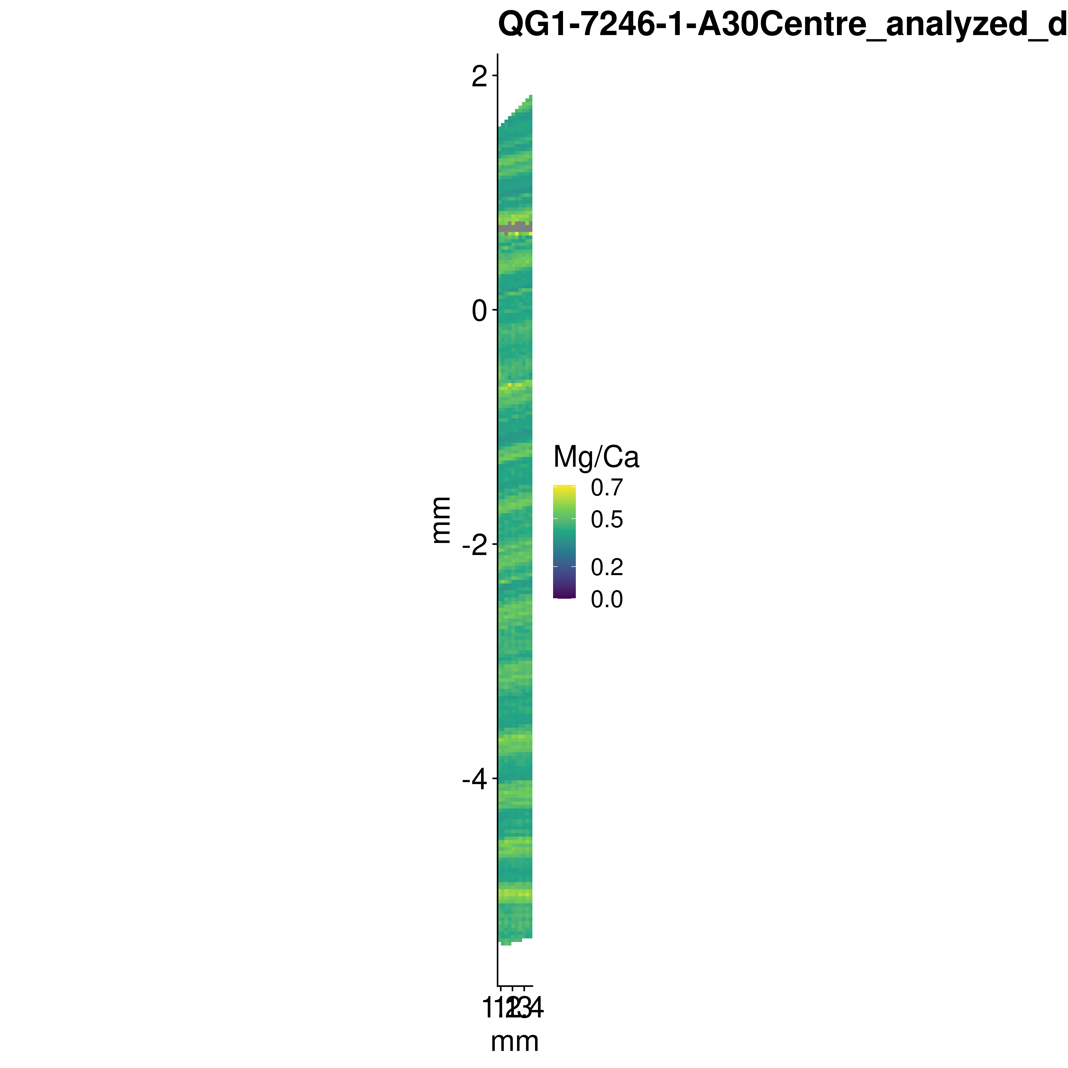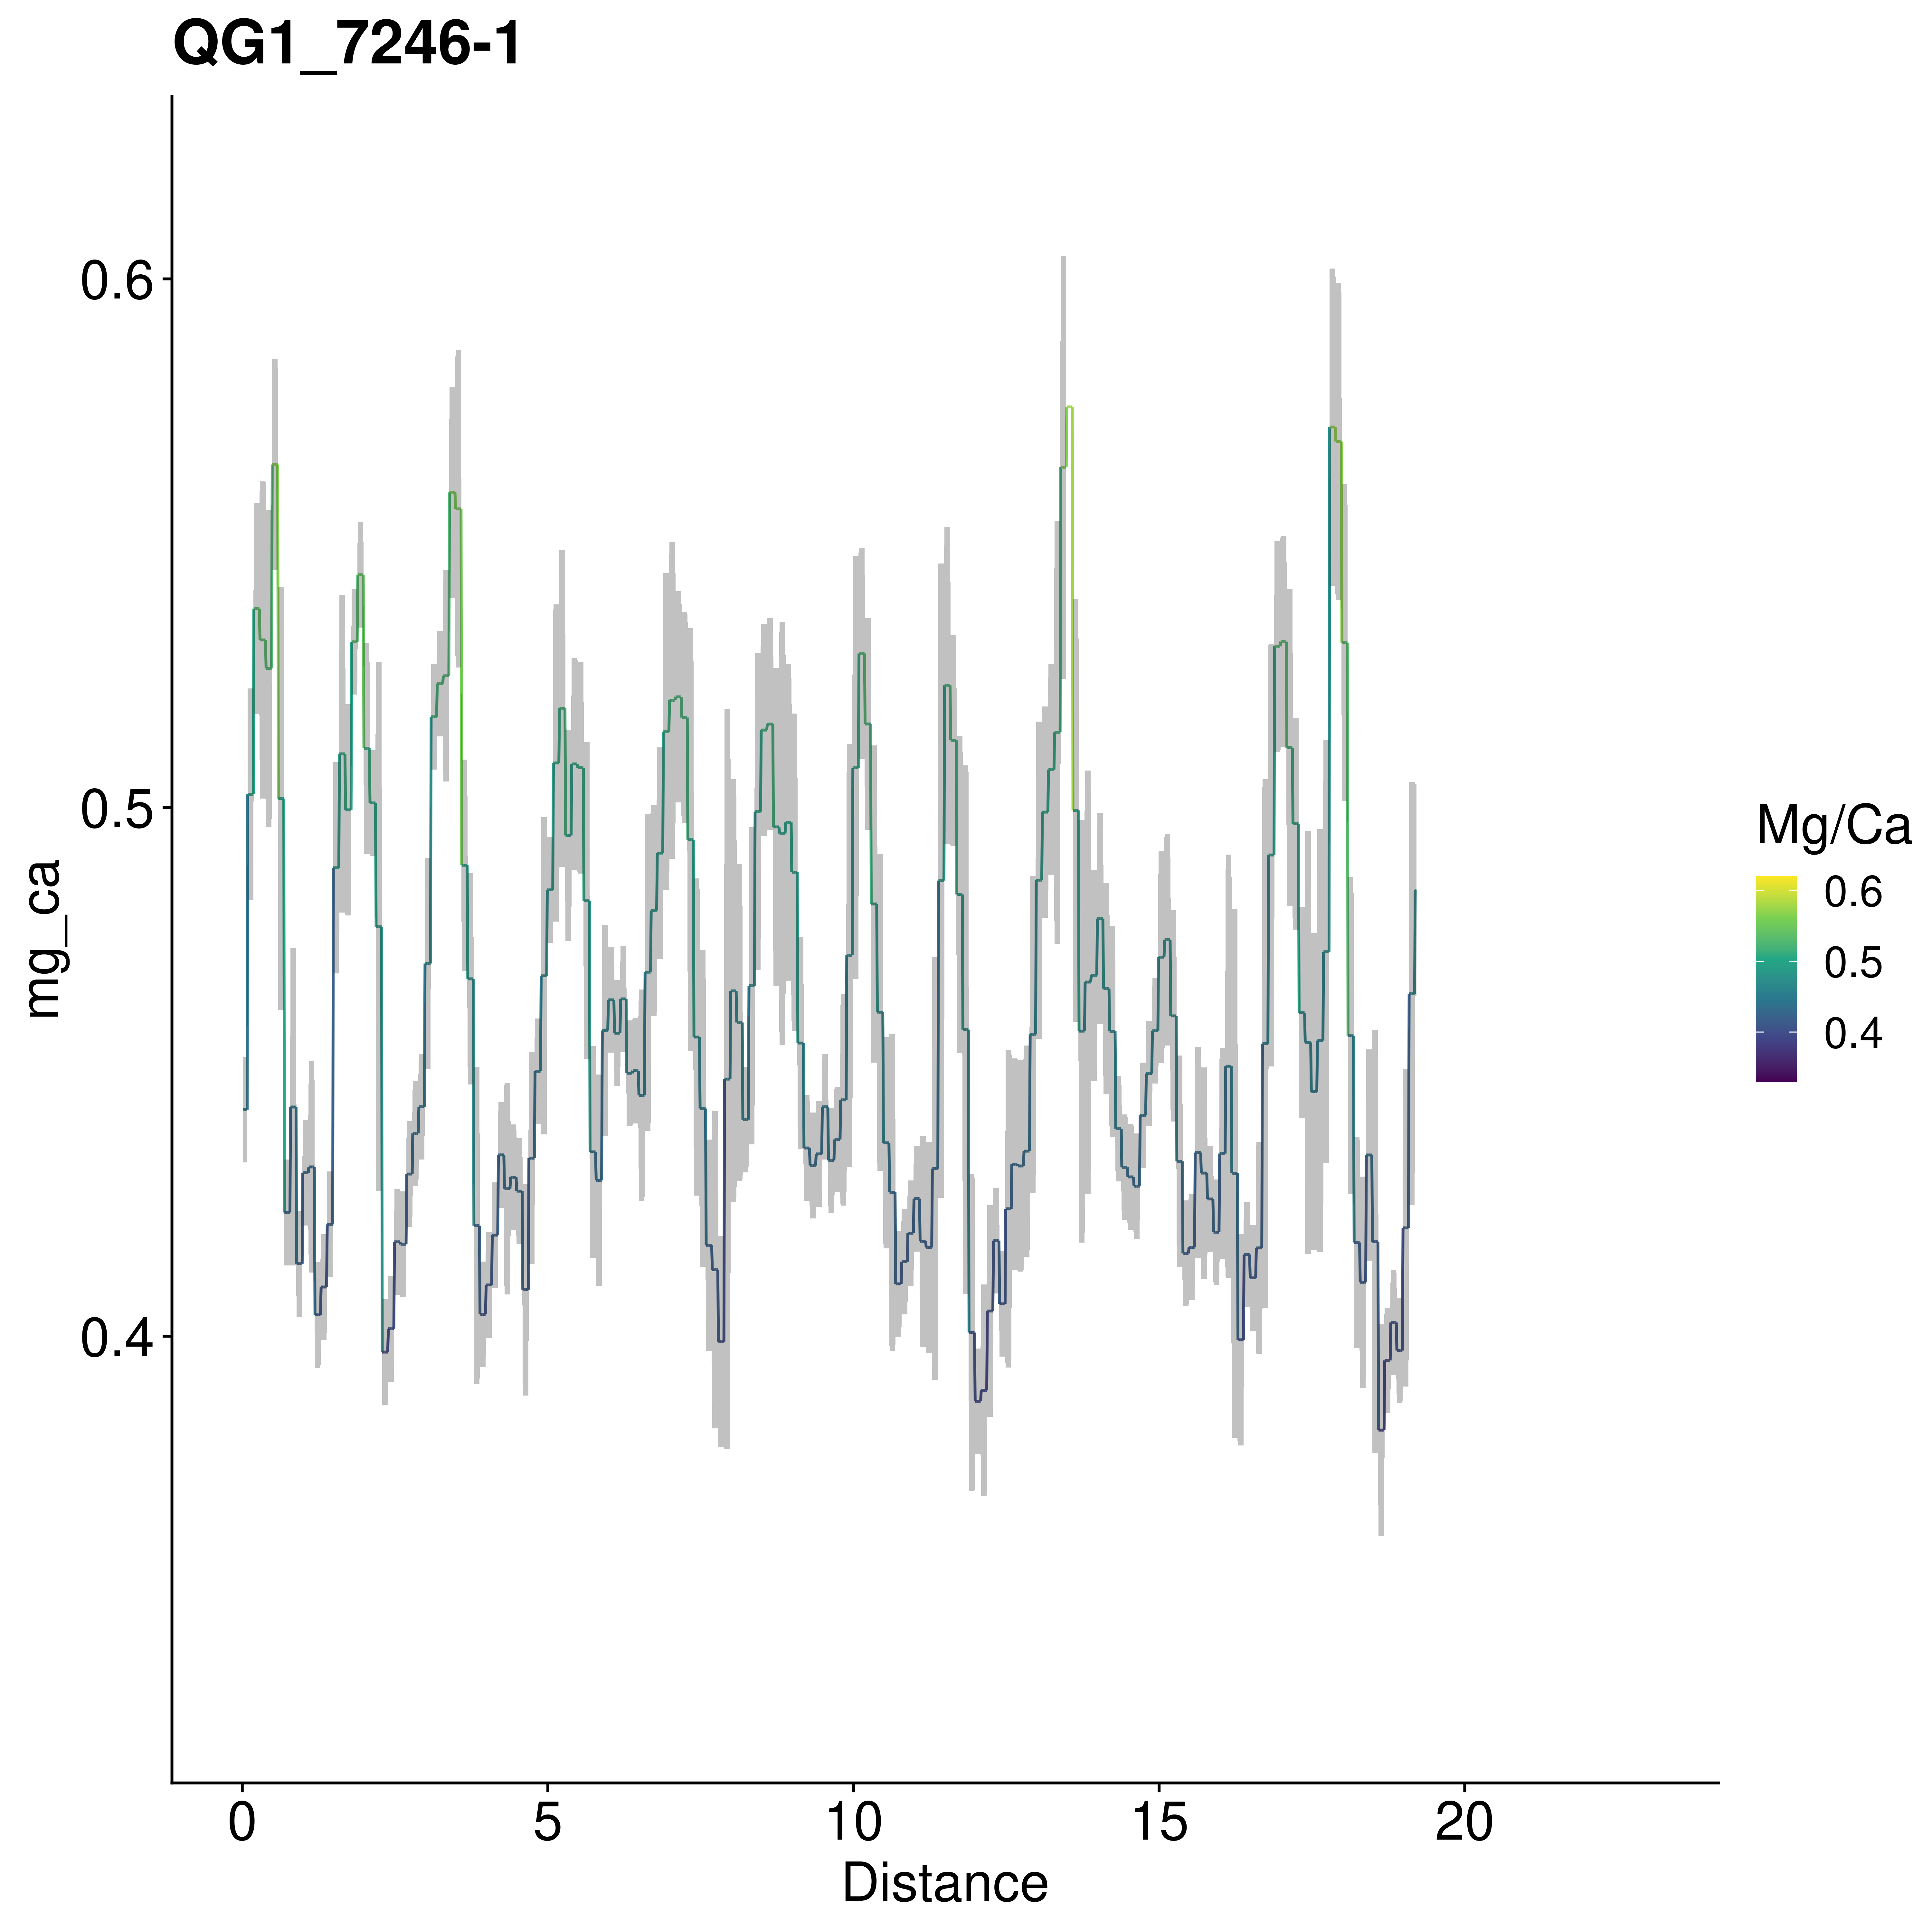

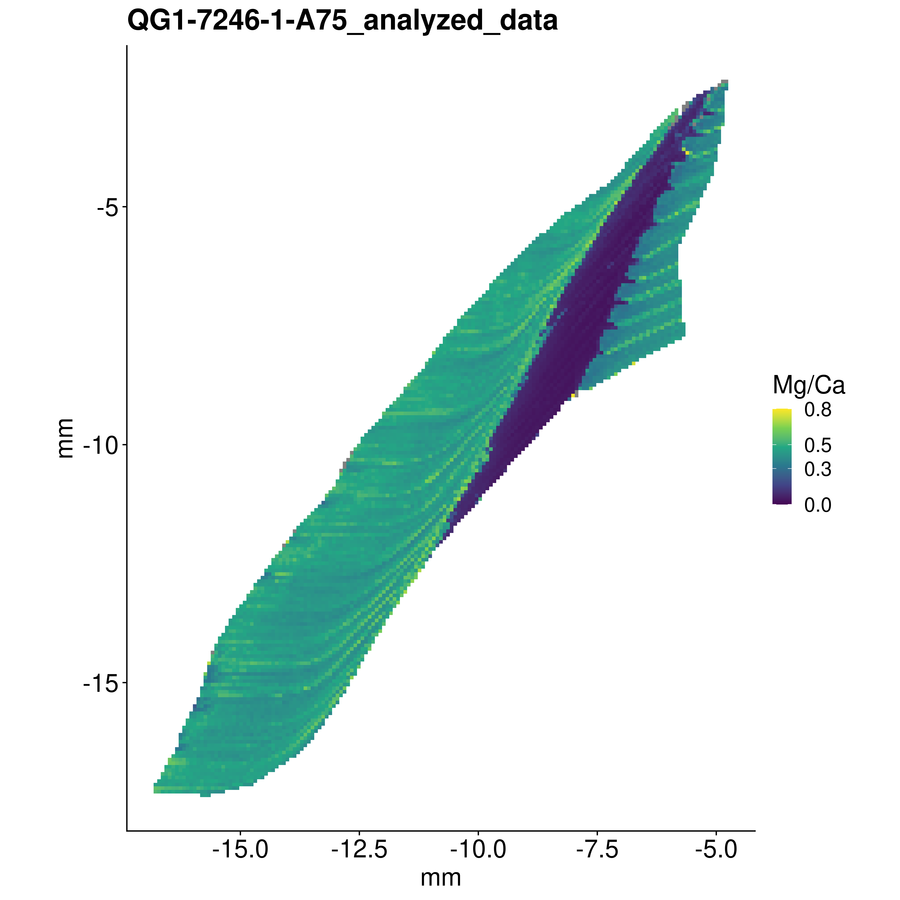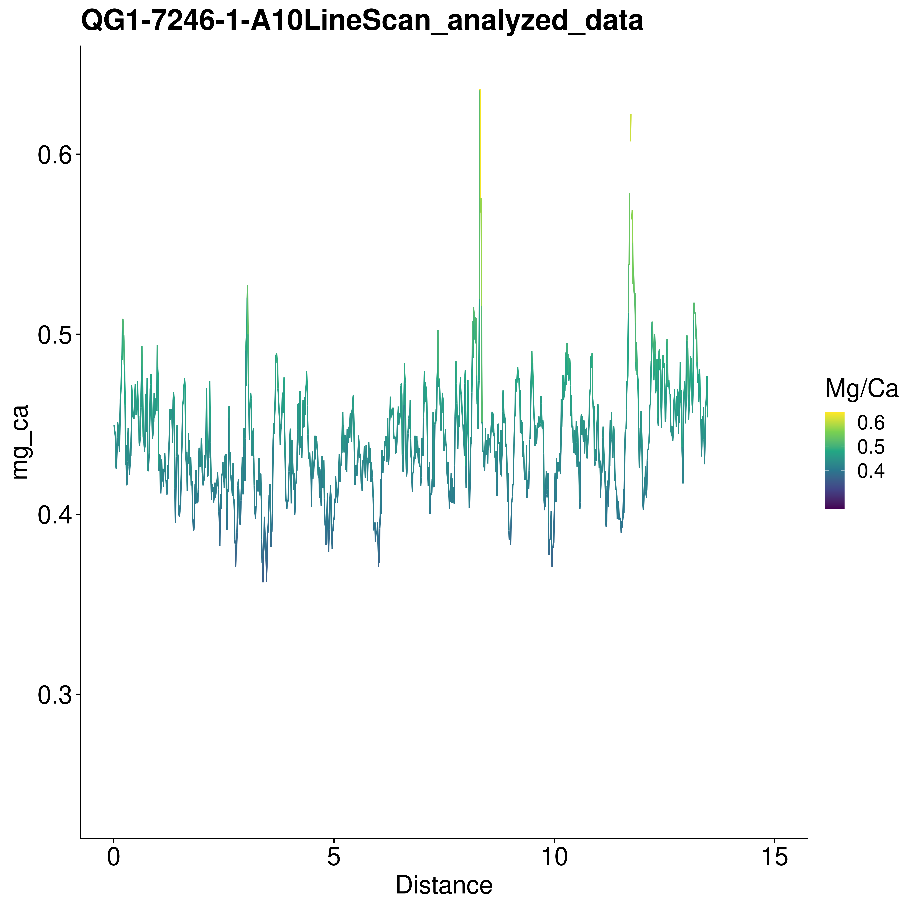

### QG2-1061-1

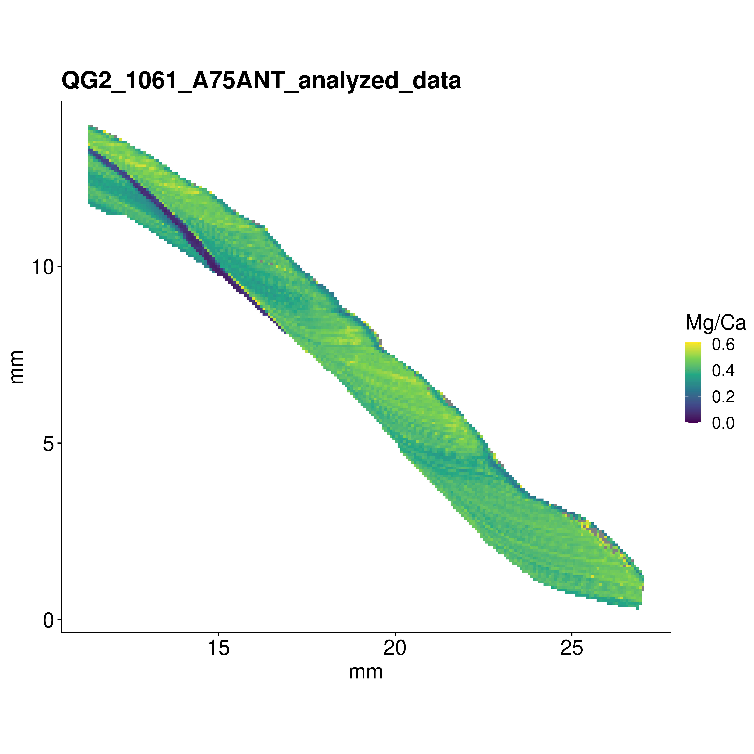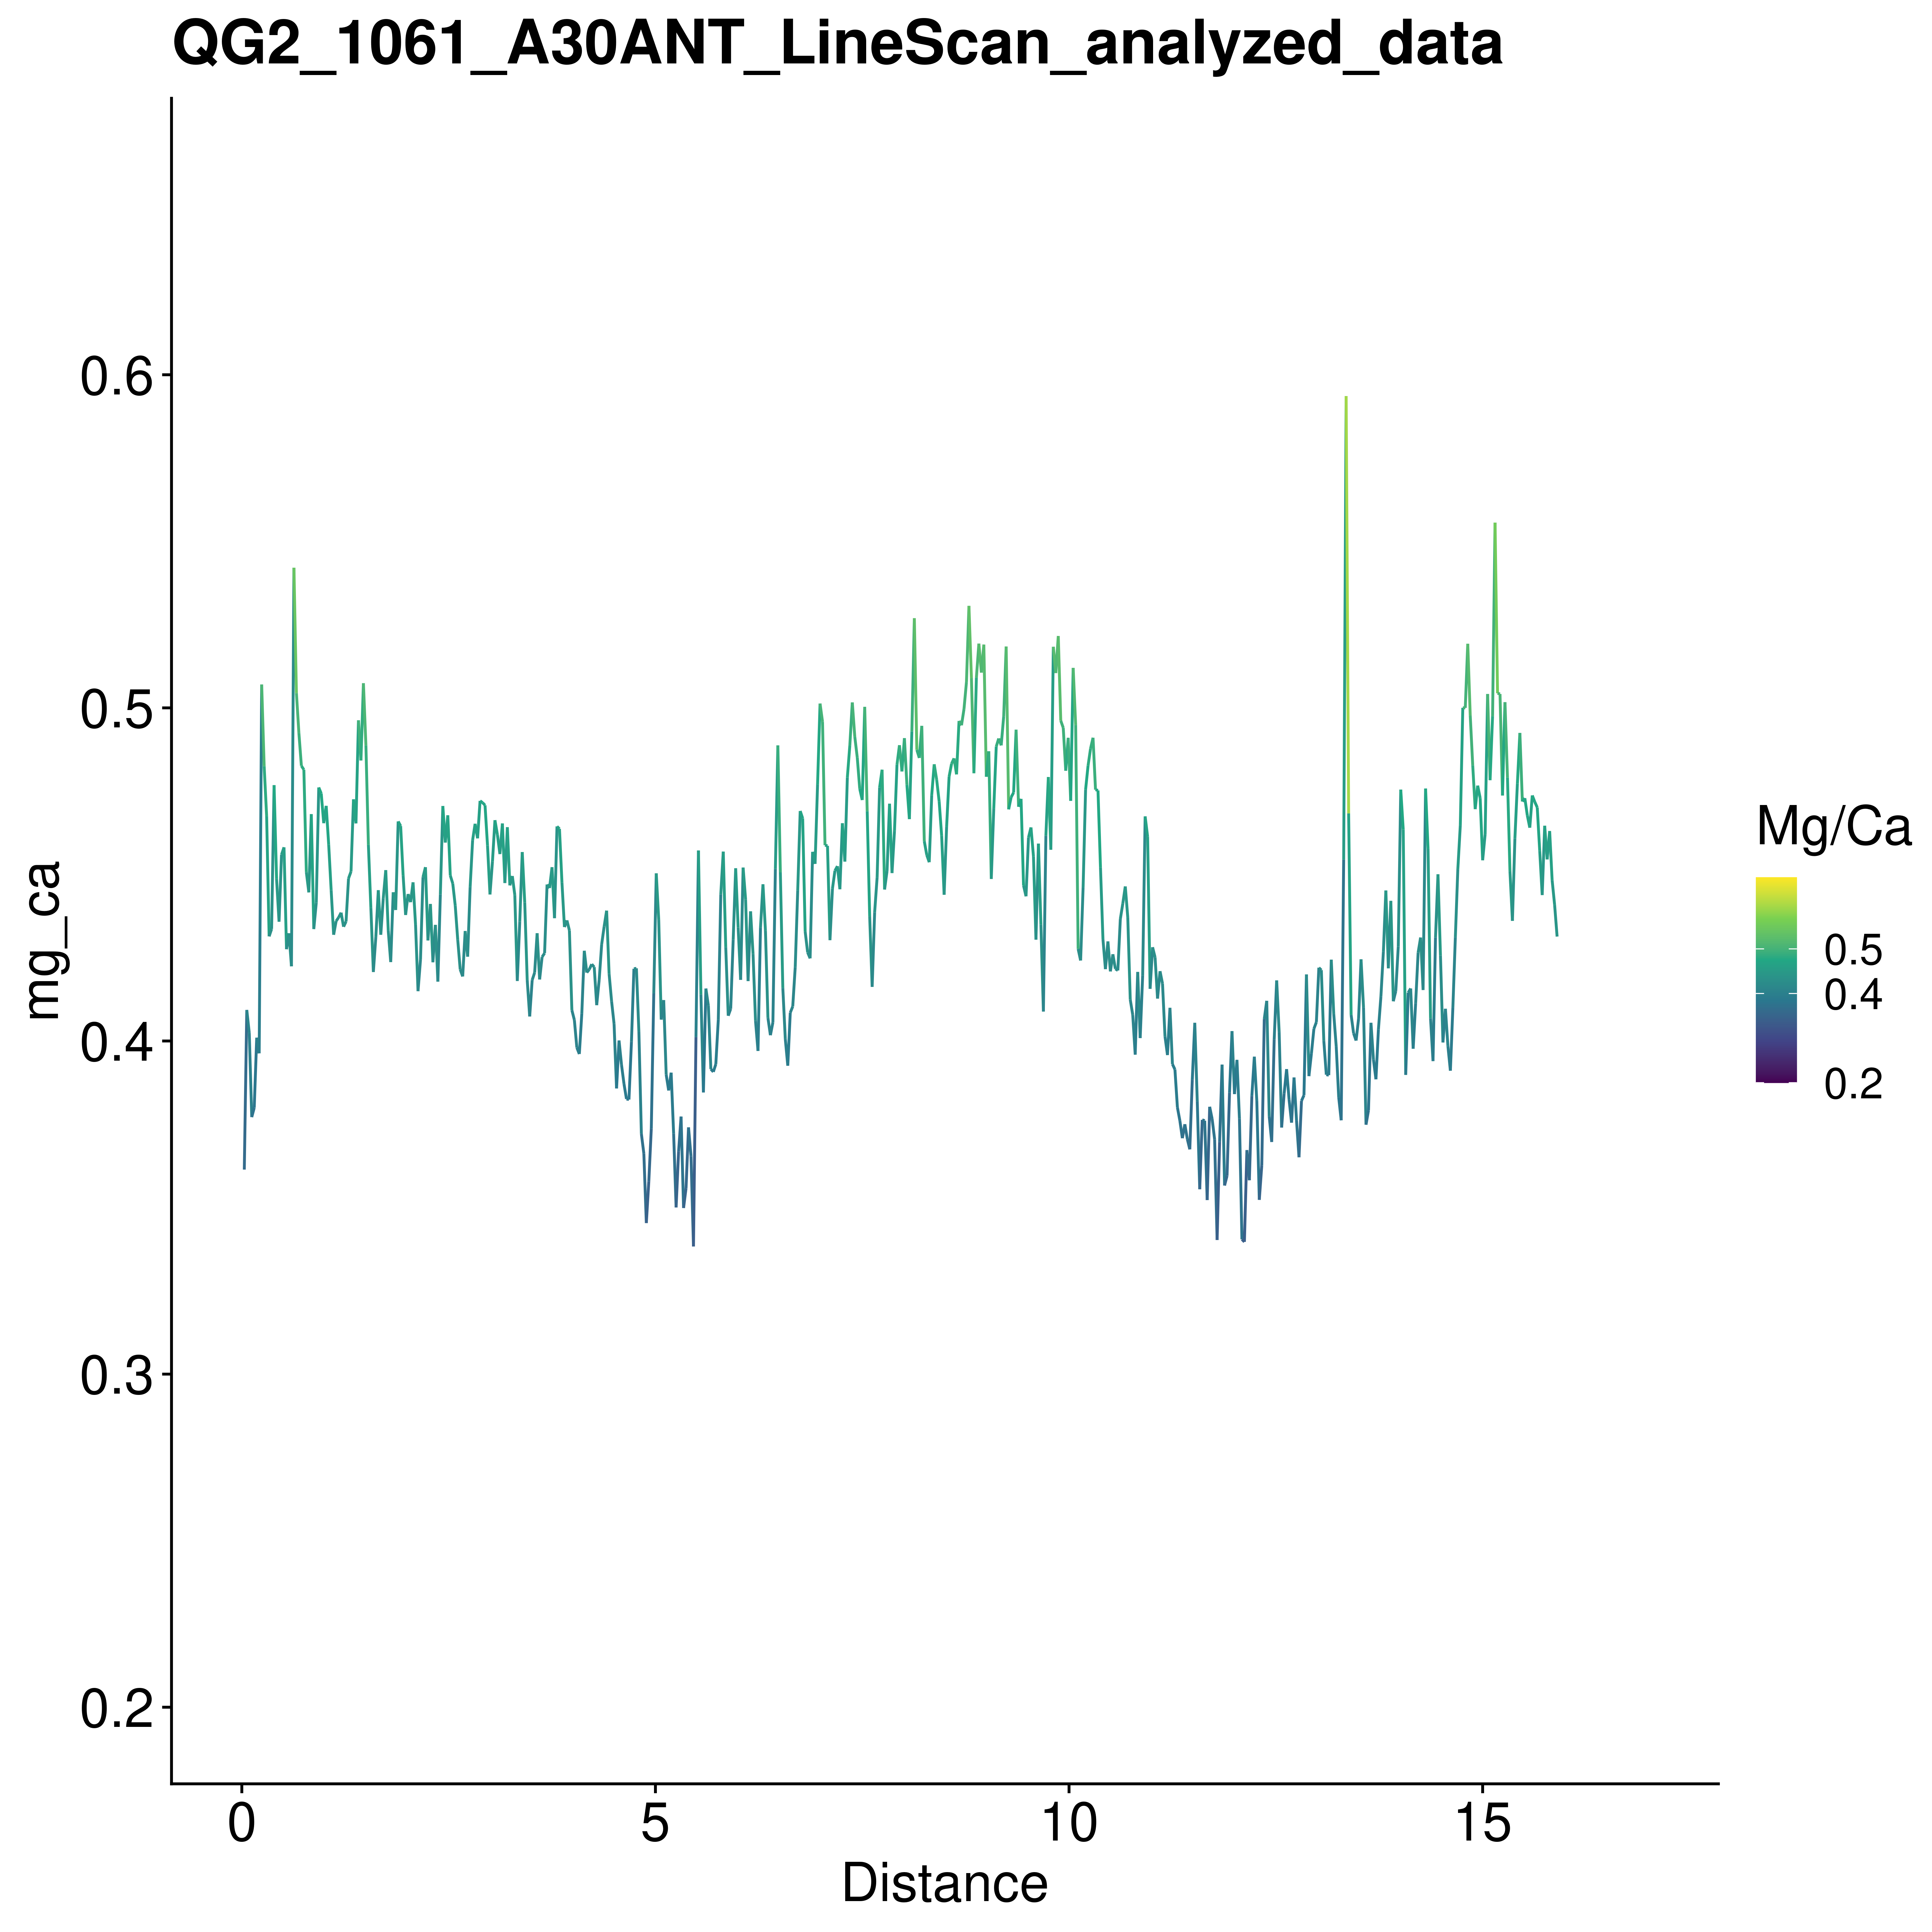

### QG2-7180-1

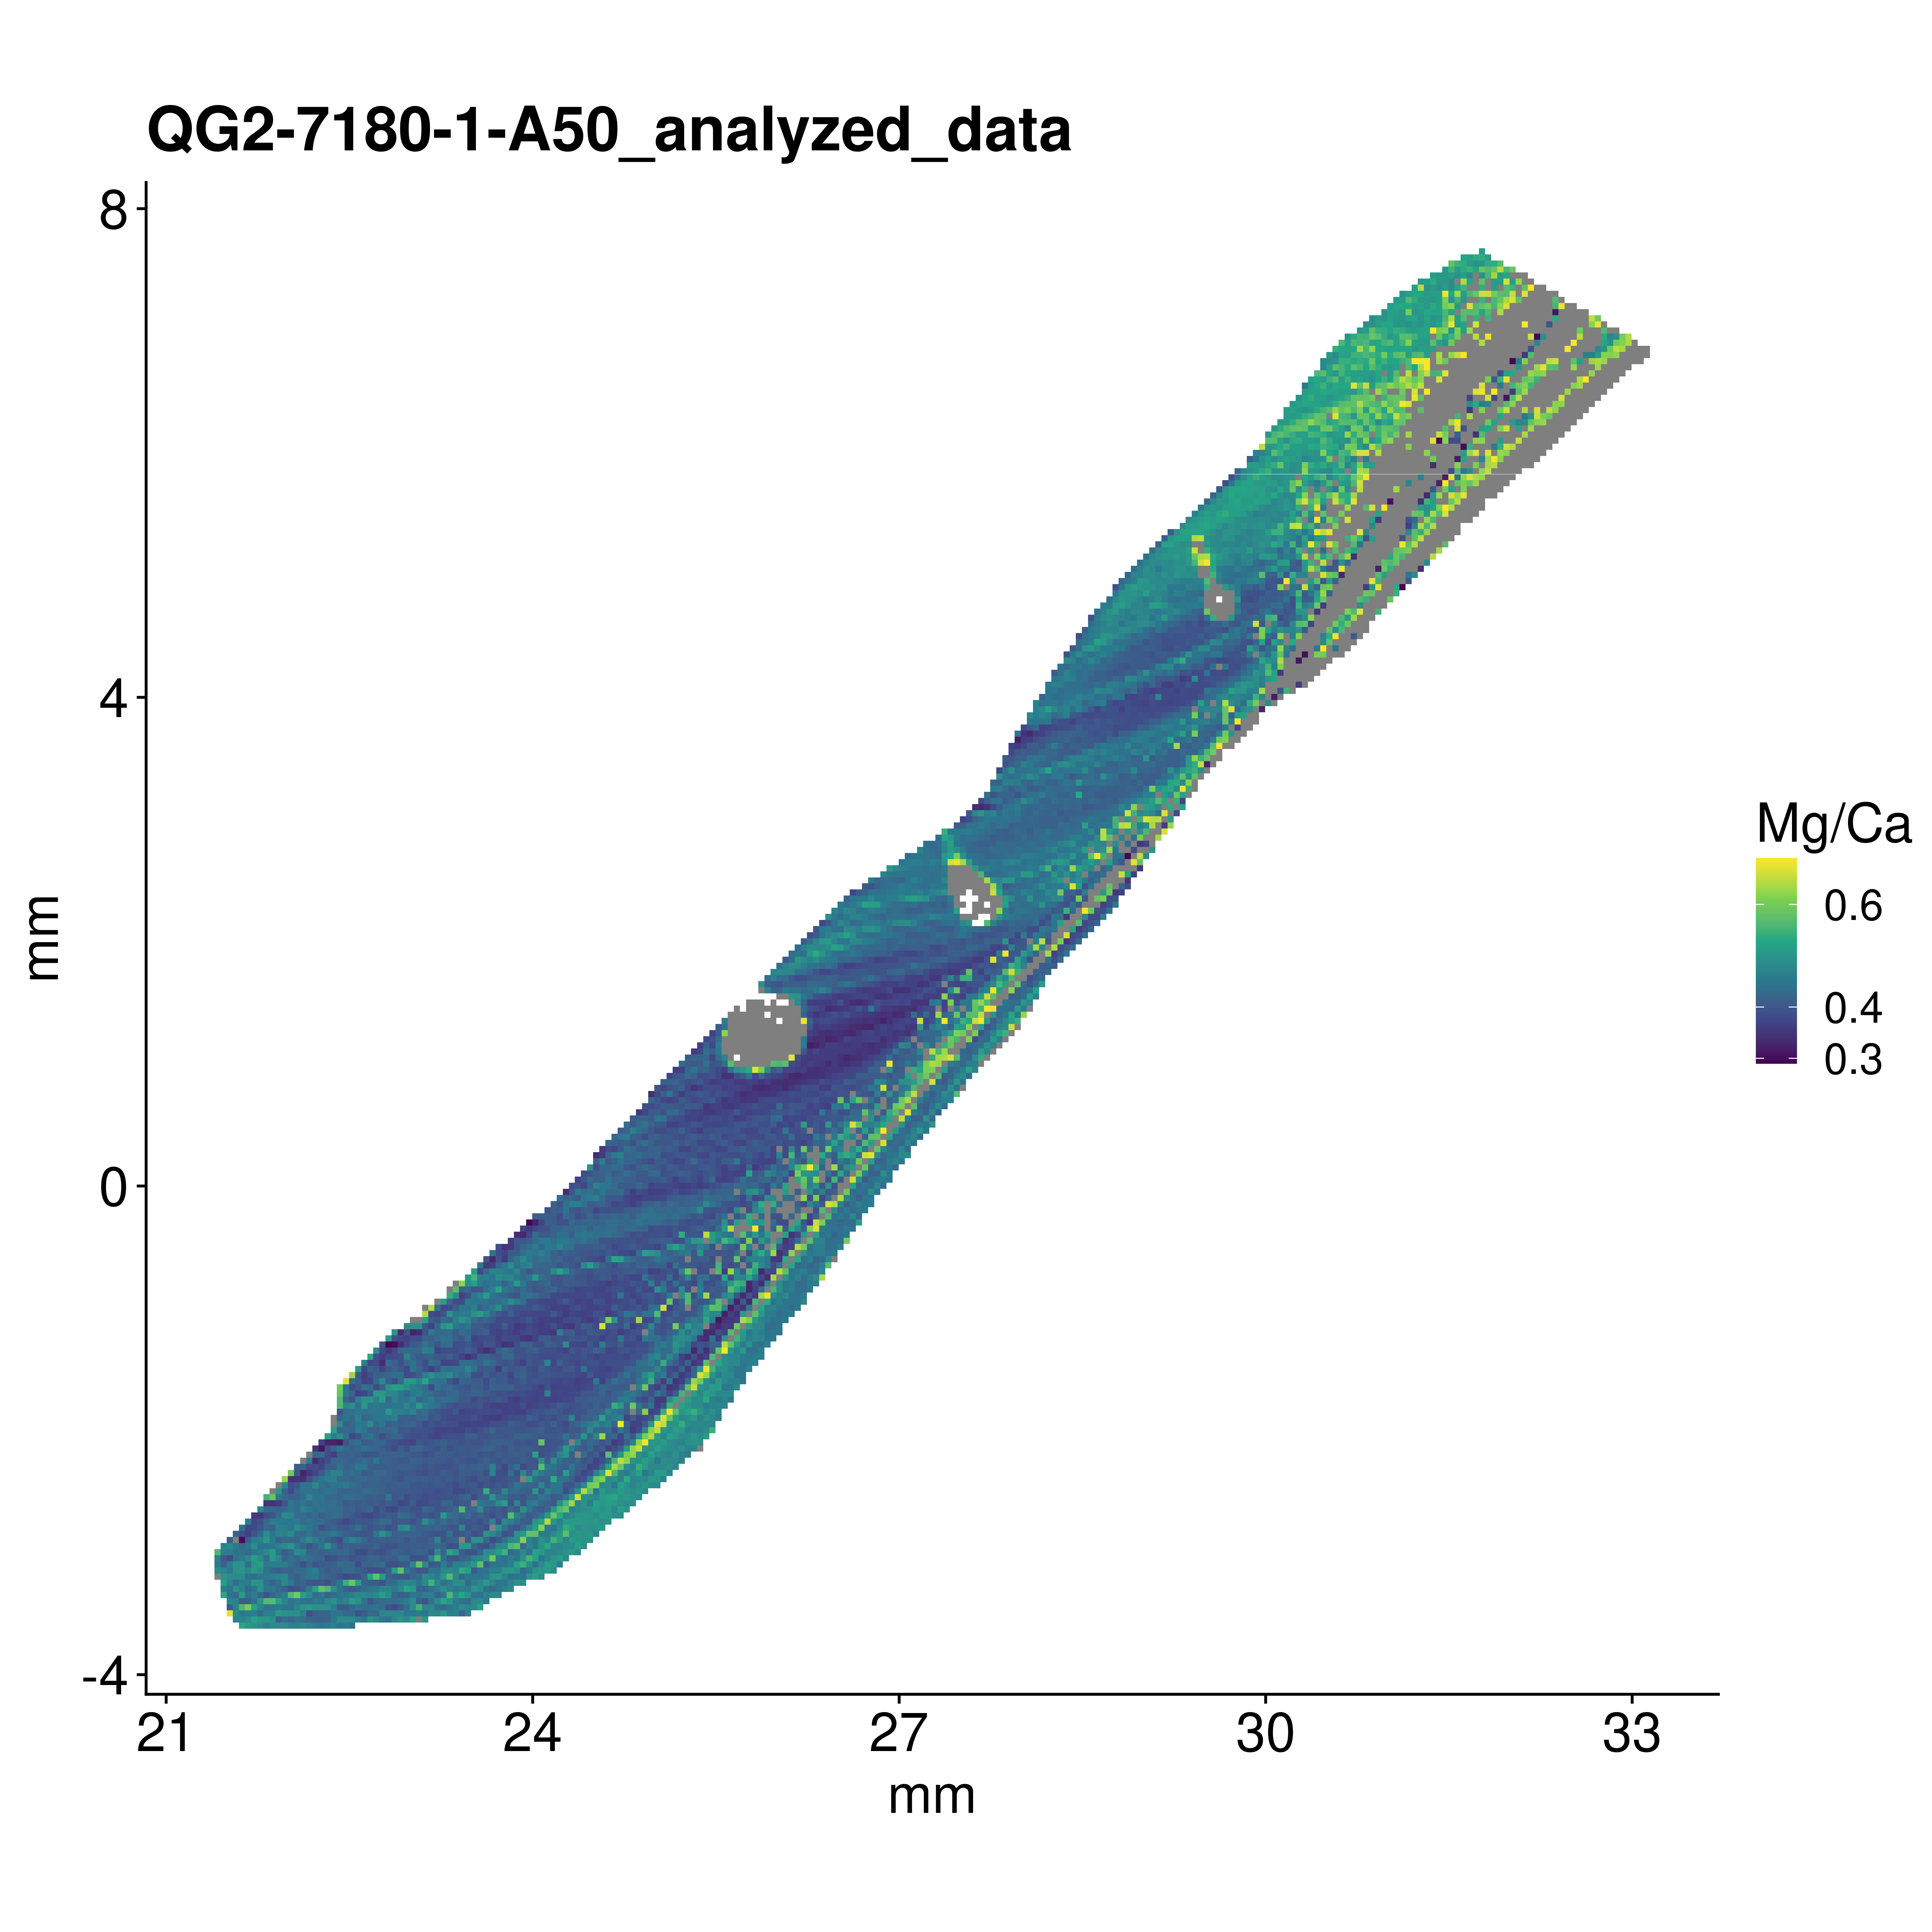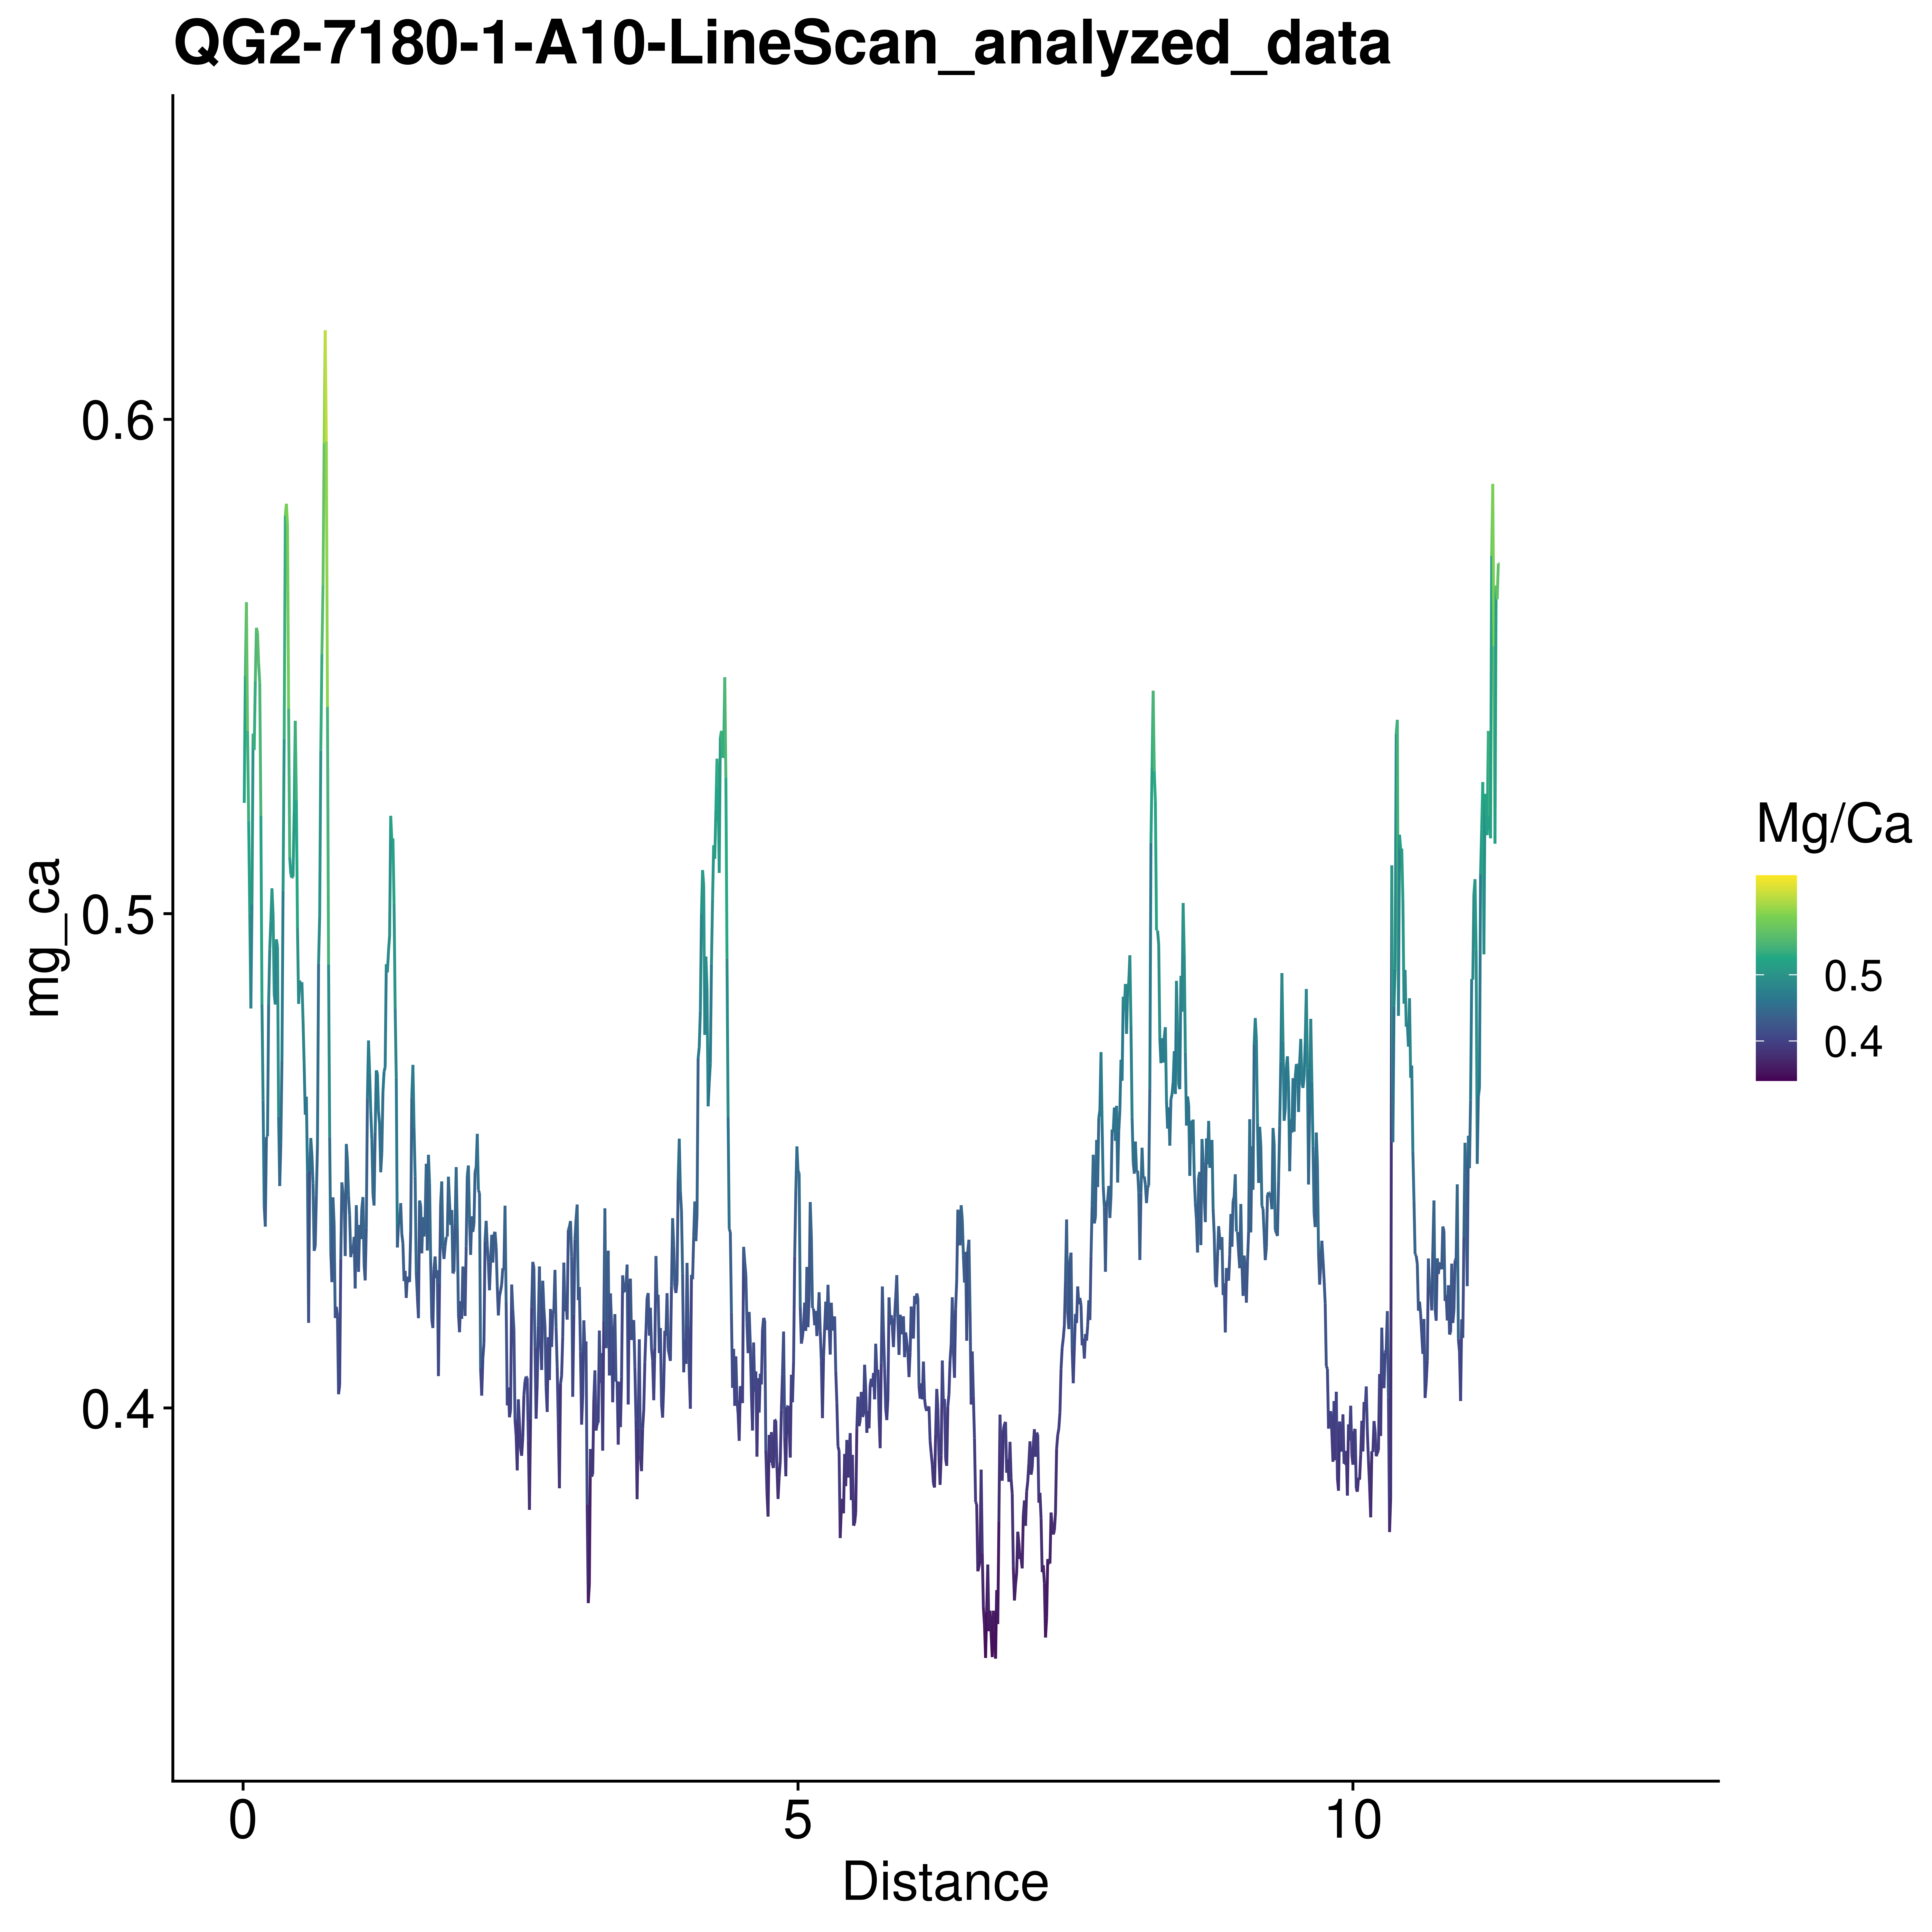

### QG2-7188-1

